**System Manual.**

FILE

* 1. Log In

# : How to log in the school system

This topic assumes that the system is installed in the computer that you are using.

1. Double click the SB School icon .
2. The login screen shown below appears.

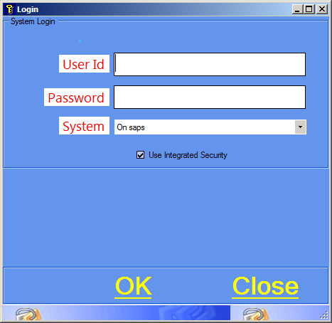

Figure Login Screen

1. Key in your user id and password (for the first time, ask the system administrator for the username and password) and click ok.
2. If the User Id and password are ok, the system opens the main menu screen shown below

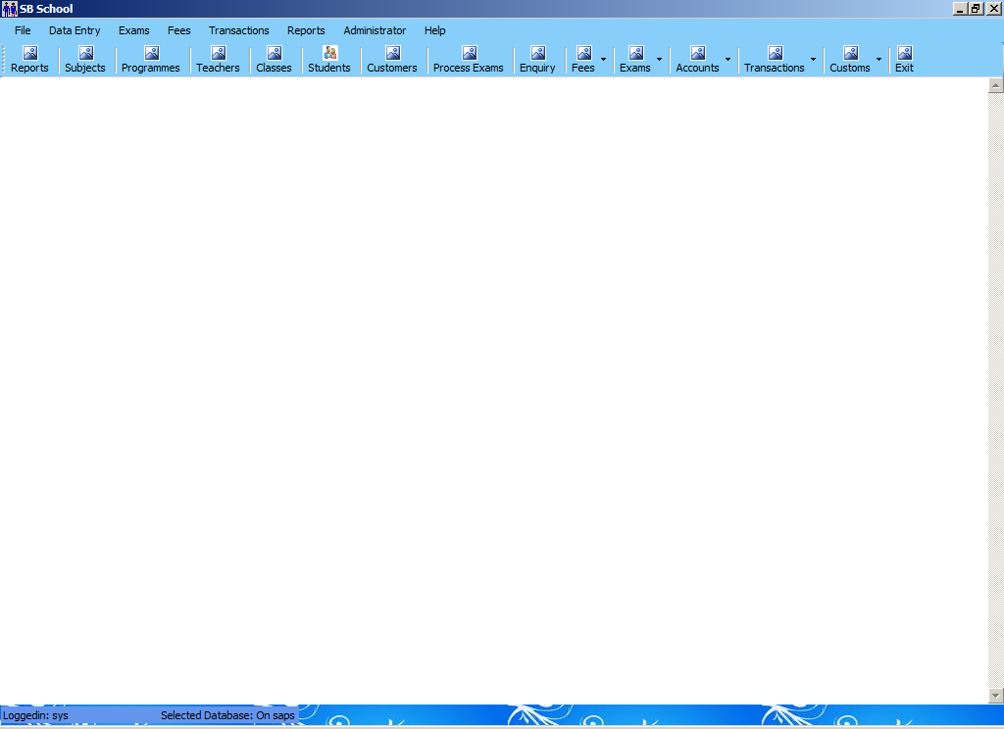

* 1. Change Password

# : How to change your log in password

1. From the File menu, click change password
2. The system opens the screen below.

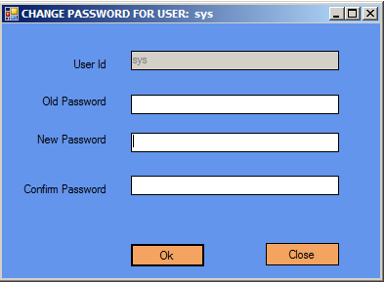

1. Type in your old and new password in the respective places and click Ok.
2. The system will log off and you can log in with your new password.
   1. Exit

# : How to exit

From the File menu, click Exit. 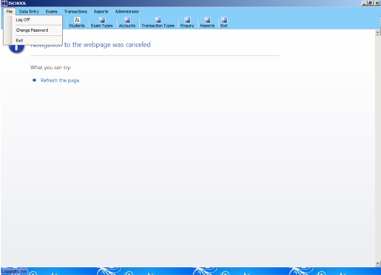

DATA ENTRY

1.1. Subject

# : How to add a Subject

1. Click Data Entry on the menu bar.
2. Click Subjects.
3. The screen shown below will appear.

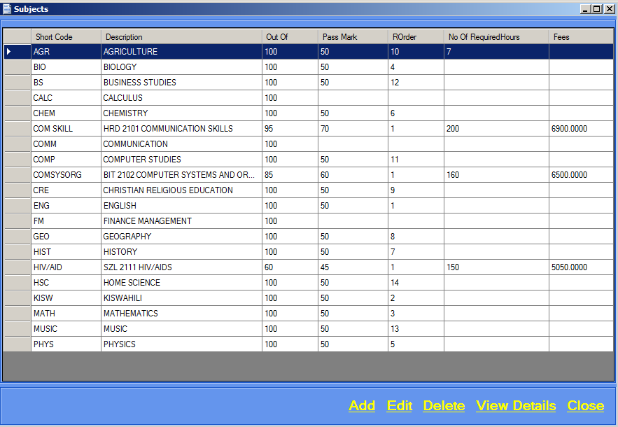

Figure Subjects Screen

1. Click Add, a screen will appear as shown below.

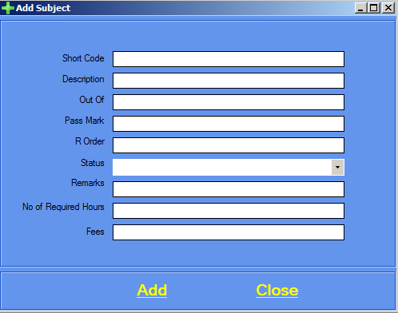

1. Add subject details.
2. Click Add then Close.

# : How to edit a Subject

1. Click Data Entry on the menu bar.
2. Click Subjects.
3. Figure 7 will appear.
4. Select the Subject you want to edit, as shown below.

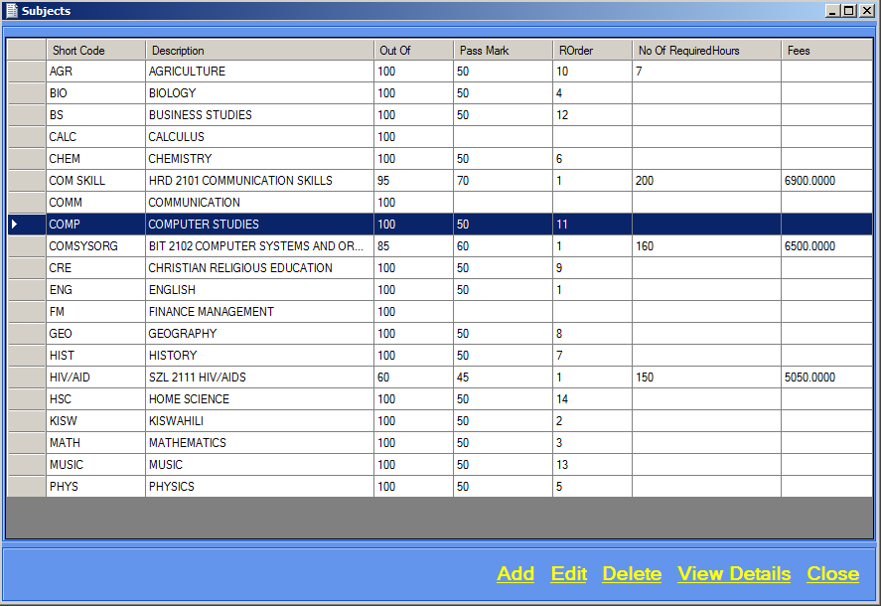

1. Click Edit, the screen below will appear.

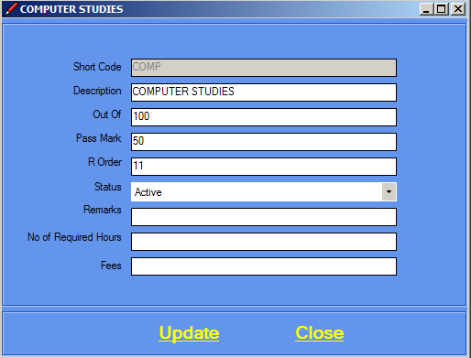

1. Edit subject details.
2. Click Update then Close.

# : How to delete a Subject

1. Before trying to delete a subject make sure that you have first deleted the programme year course associated with the subject.
2. Click Data Entry on the menu bar.
3. Click Subjects.
4. Figure 7 will appear.
5. Select the Class you want to delete. See Figure 8.
6. Click Delete.
7. The screen below will appear.

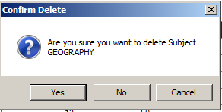

1. Confirm deletion by clicking Yes.
2. Click Close.

# : How to view Subject details

1. Click Data Entry on the menu bar.
2. Click Subjects.
3. Figure 7 will appear.
4. Select a Subject. See example of Figure 8.
5. Click View Details, a screen will appear with the subject details as shown below.

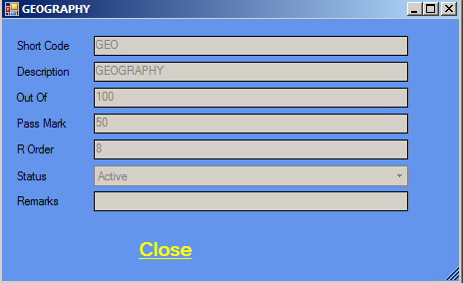

1. Click Close.

1.2. Programme

# : How to add a Programme

1. Click Data Entry on the menu bar.
2. Click Programmes.
3. The screen shown below will appear.

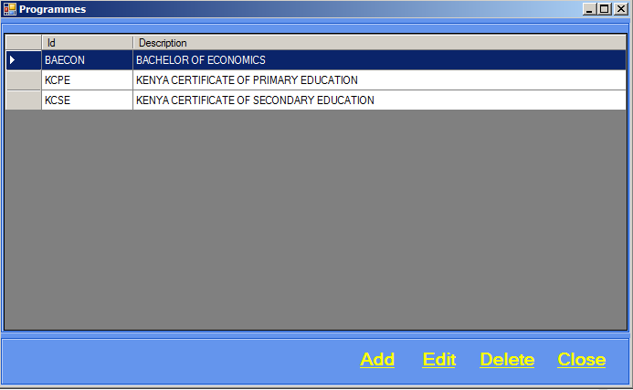

Figure Programmes Screen

1. Click Add, a screen will appear as shown below.

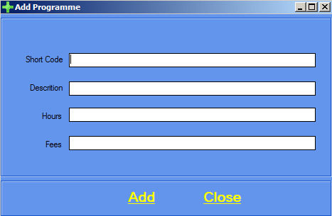

1. Add programme details.
2. Click Add then Close.

# : How to edit a Programme

1. Click Data Entry on the menu bar.
2. Click Programmes.
3. Figure 9 will appear.
4. Select the Programme you want to edit, as shown below.

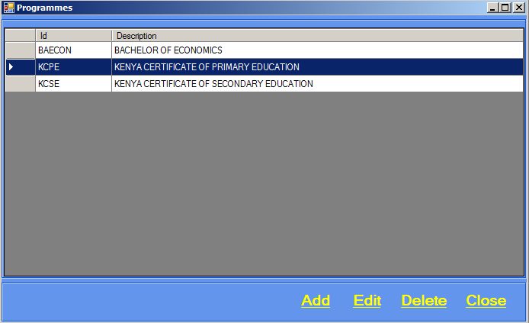

Figure Selecting a Programme

1. Click Edit, the screen below will appear.

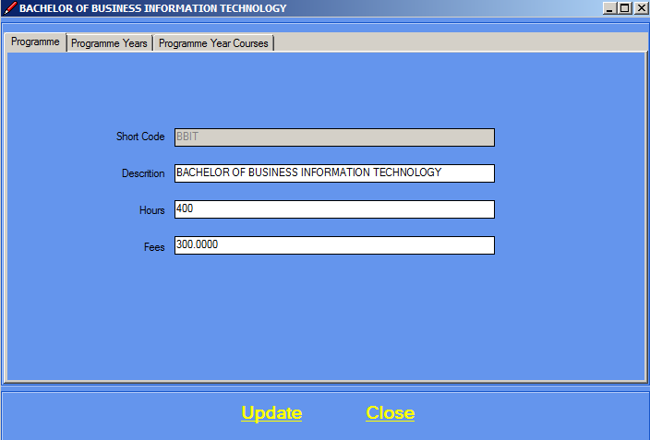

1. Edit programme details.

**Programme Years**

1. Click Programme Years tab, the screen below appears.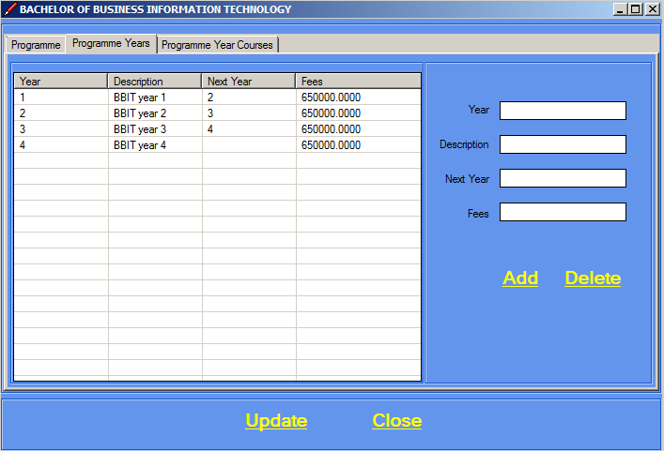
2. Year and description are mandatory.
3. Click on add to add a programme year.
4. 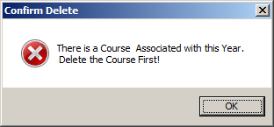You cannot delete a programme year if there are programme year courses associated with it.
5. To delete a programme first delete the programme year courses associated with it.
6. Click on delete to delete a programme year.

**PROGRAMME** **YEARS** **COURSES**

1. Click Programme Years Courses tab, the screen below appears.

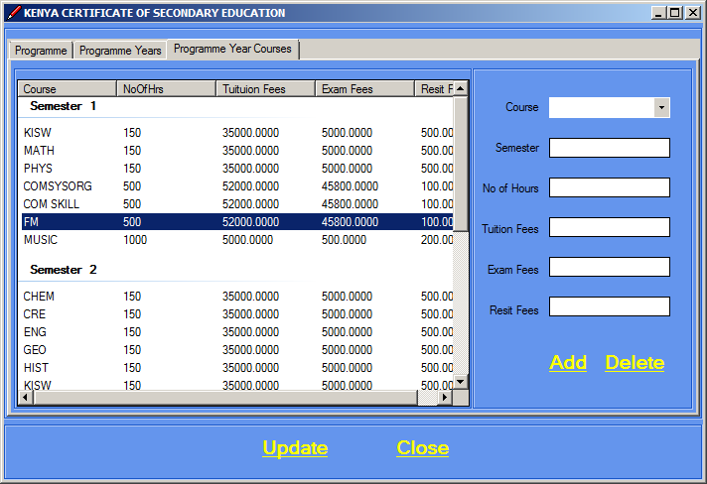

1. To add a programme year course you must first select a programme year.
2. Course and semester are mandatory.
3. Click on Add to add a programme year course.
4. Click on Delete to delete a programme year course.
5. Click Update then Close.

# : How to delete a Programme

1. Click Data Entry on the menu bar.
2. Click Programmes.
3. Figure 9 will appear.
4. Select the Programme you want to delete. See Figure 10.

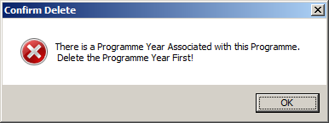

1. You must first delete the programme years associated with it.
2. See chapter 9 on how to delete a programme year.
3. After deleting the programme years associated with the programme you want to delete,click Delete.
4. The screen below will appear.

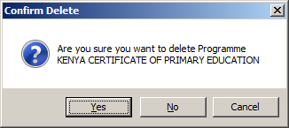

1. Confirm deletion by clicking Yes.
2. Click close.

1.3. Teacher

# : How to add a Teacher

1. Click Data Entry on the menu bar.
2. Click Teachers.
3. The screen shown below will appear.

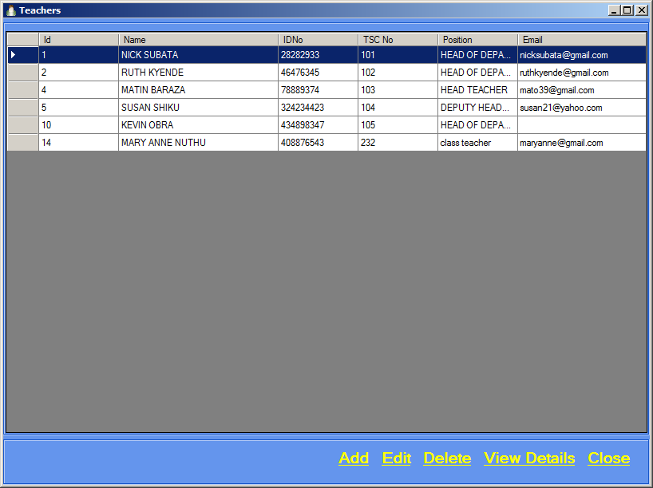

1. Click Add, a screen will appear as shown below.

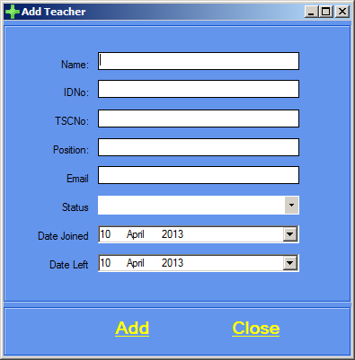

1. Name and ID number are mandatory.
2. Type in the Teacher’s details.
3. Click Add then Close.

# : How to edit a Teacher

1. Click Data Entry on the menu bar.
2. Click Teachers.
3. Figure 2 will appear.
4. Select the Teacher you want to edit, as shown below.

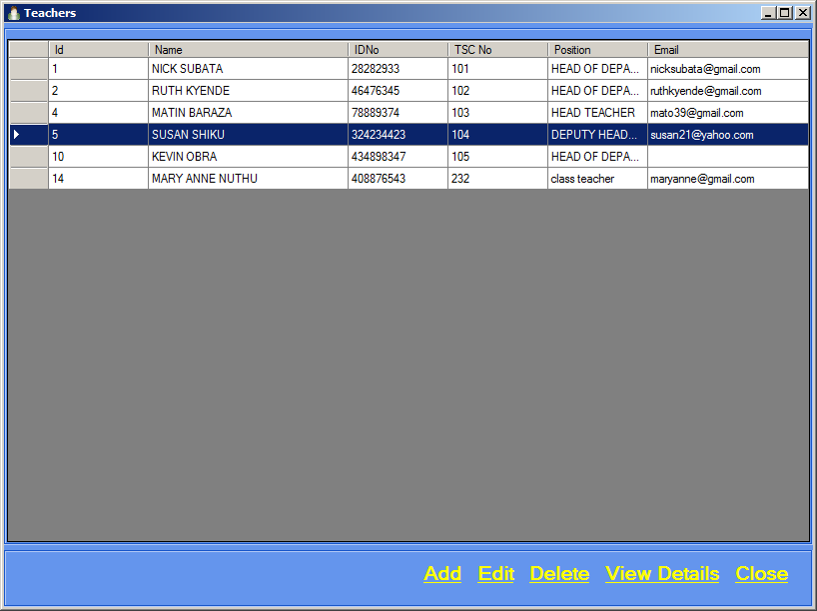

Figure Select a Teacher

1. Click Edit, the screen below will appear.

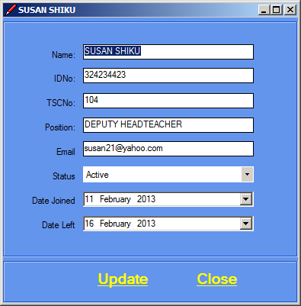

1. Edit teacher details, click Update then Close.

# : How to delete a Teacher

1. You cannot delete a teacher if the teacher is associated with a class subject
2. You must first delete the class subjects associated with the teacher before deleting a teacher.
3. After deleting the class subjects associated with the teacher.
4. Click Data Entry on the menu bar.
5. Click Teachers.
6. Figure 2 will appear.
7. Select the Teacher you want to delete.
8. Click Delete.
9. The screen below will appear.

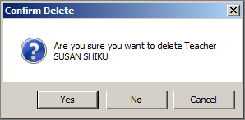

1. Confirm deletion by clicking Yes.
2. Click Close.

# : How to view Teacher details

1. Click Data Entry on the menu bar.
2. Click Teachers.
3. Figure 2 will appear.
4. Select a Teacher.
5. Click View Details, a screen will appear with the teacher details as shown below.

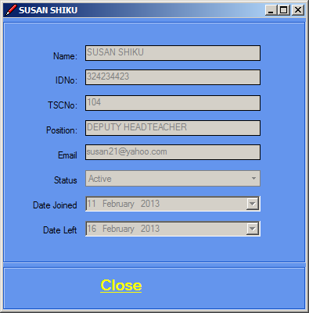

1. Click Close after viewing the teacher details.

1.4. Classes

# : How to add a class

1. Click Data Entry on the menu bar.
2. Click Classes.
3. The screen shown below will appear.

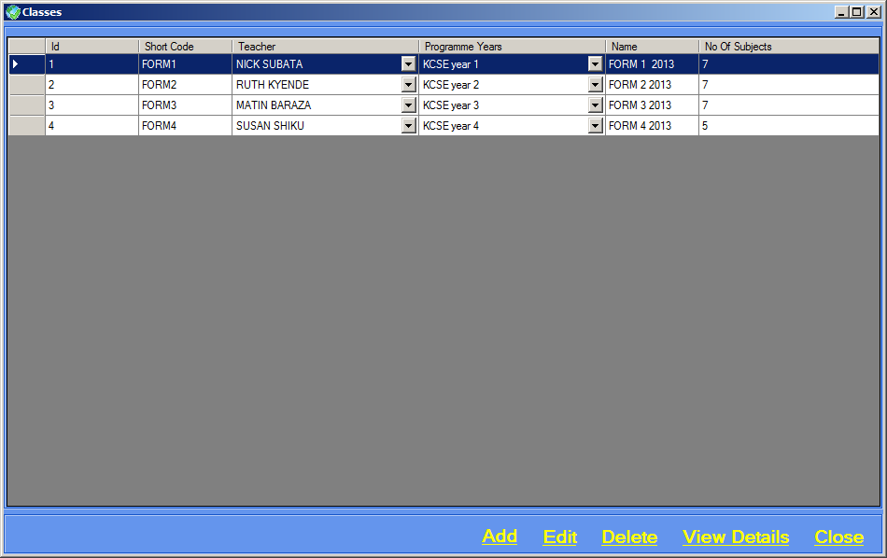

Figure Class Screen

1. Click Add, a screen will appear as shown below.

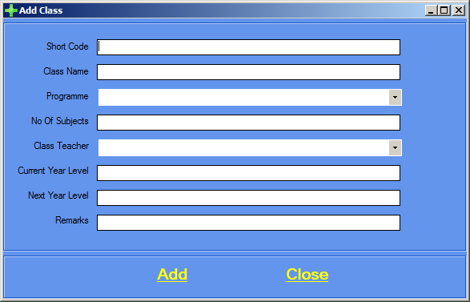

1. Type in the Class details.
2. Click Add then Close.

# : How to edit a Class

1. Click Data Entry on the menu bar.
2. Click Classes.
3. Figure 4 will appear.
4. Select the Class you want to edit, as shown below.

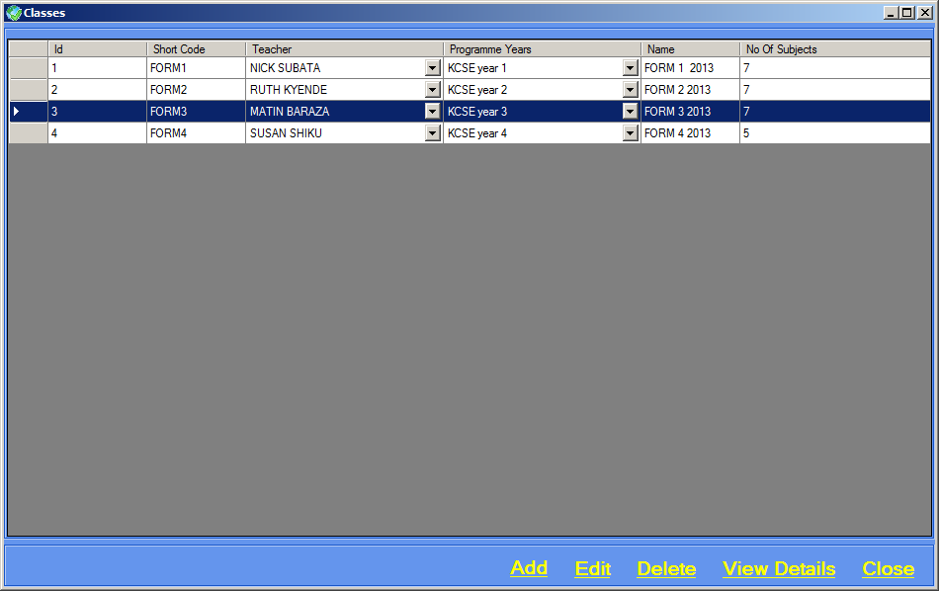

Figure Selecting a Class

1. Click Edit, the screen below will appear.

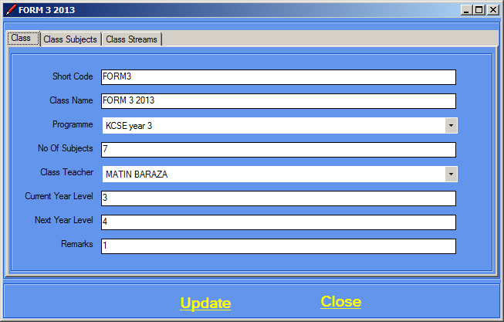

1. Edit class details.

**Class** **Subjects**

1. Click on the Class Subjects tab, the screen below will appear.

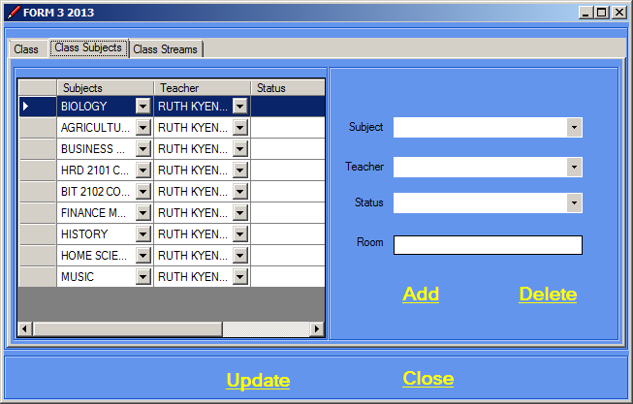

1. Subject and teacher are mandatory.
2. Click Add.
3. To delete a class subject you must first ensure that there are no exams associated with it.
4. Delete the exam first then delete the class subject.

**Class** **Streams**

1. Click on the Class Streams tab, the screen below will appear.

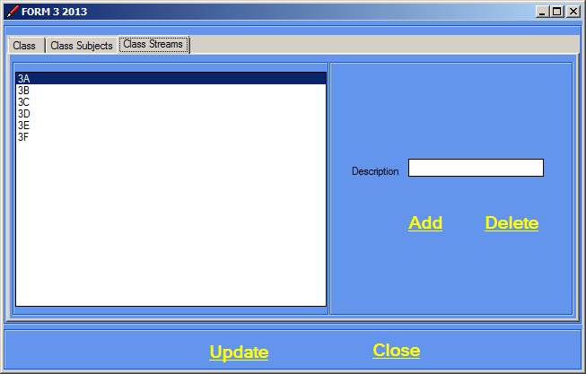

1. Type the description.
2. Click Add then Update.
3. To delete a class stream you must first ensure that there are no students associated with it.
4. Delete the students first then delete the class stream.
5. Click Update then Close.

# : How to delete a Class

1. You cannot delete a class if there is a class stream associated with it.
2. Click Data Entry on the menu bar.
3. Click Classes.
4. Figure 4 will appear.
5. Select the Class you want to delete.
6. Click Delete.
7. The screen below will appear.

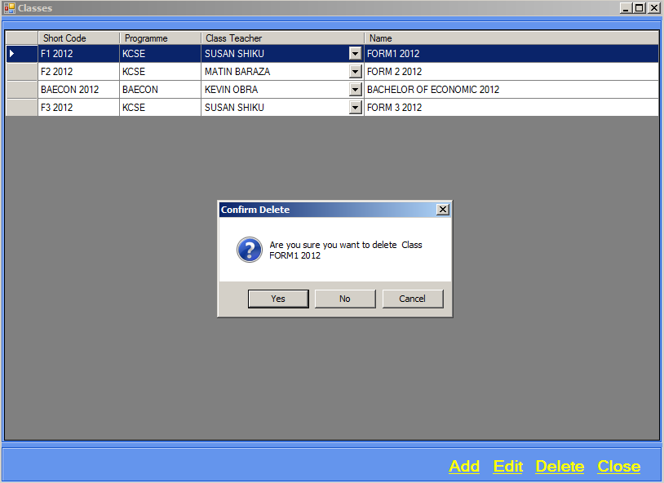

1. Confirm deletion by clicking Yes
2. Click Close.

1.5. Student

# : How to add a Student

1. Click Data Entry on the menu bar.
2. Click Students.
3. The screen shown below will appear.

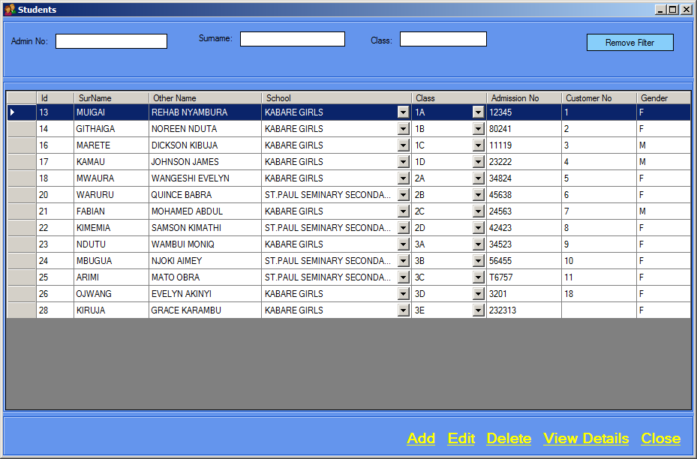

Figure Students Screen

1. Click Add, a screen will appear as shown below.

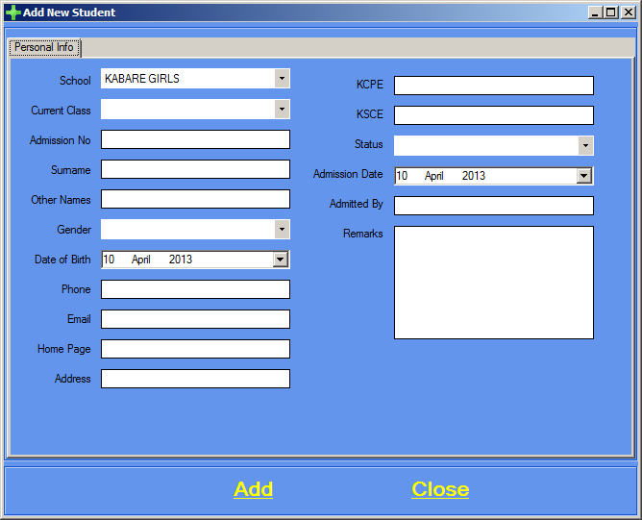

1. School, admission number, Surname, other names and gender are mandatory.
2. Click Add.

# : How to edit a Student

1. Click Data Entry on the menu bar.
2. Click Students.
3. Figure 11 will appear.
4. Select the Student you want to edit.
5. Click Edit, the screen below will appear.

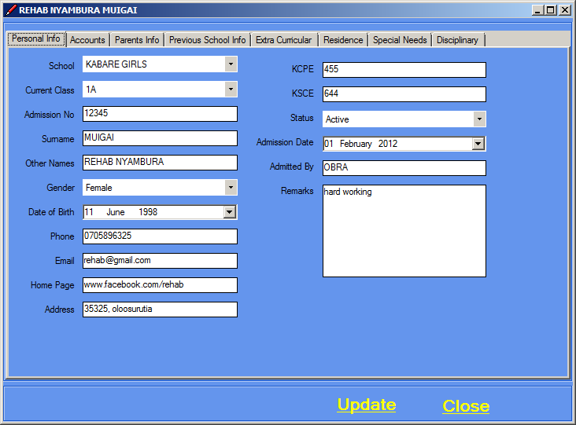

1. You can edit or add new details in the Personal Info tab.
2. Click on Accounts tab, the screen below will appear.

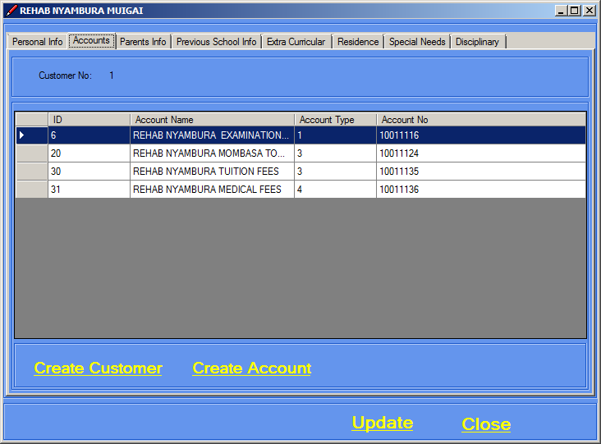

1. Click on Create Customer, the screen below appears.

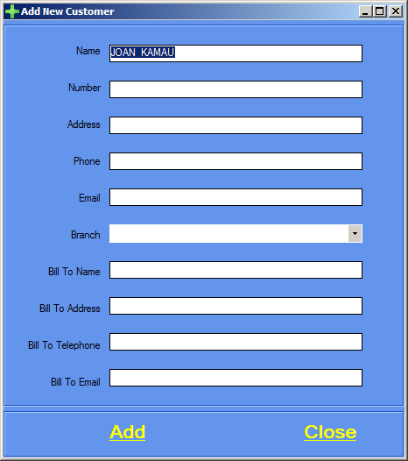

1. Type in customer details.
2. After adding a customer click on Create Account,the screen below will appear. 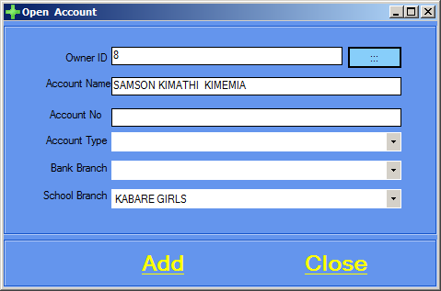
3. Add account details.
4. Click Add.
5. Click on Parents Info tab,the screen below will appear. 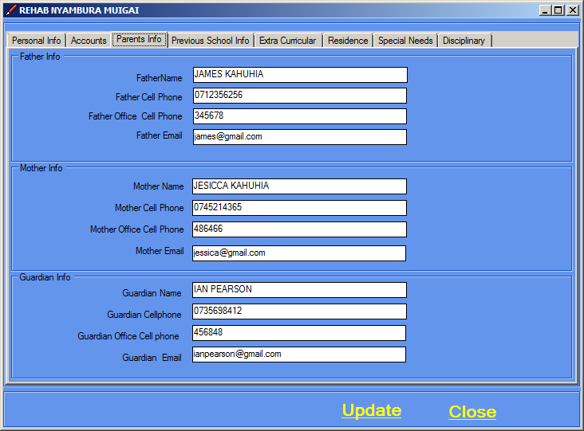
6. Add parents details as shown in example above.
7. Click on Previous School tab, the screen below will appear. 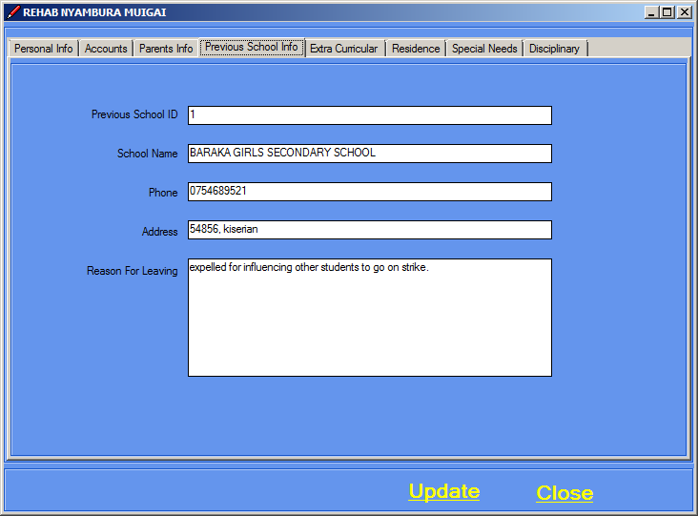
8. Previous school details is not mandatory.
9. Click on Extra Curricular tab,the screen below will appear. 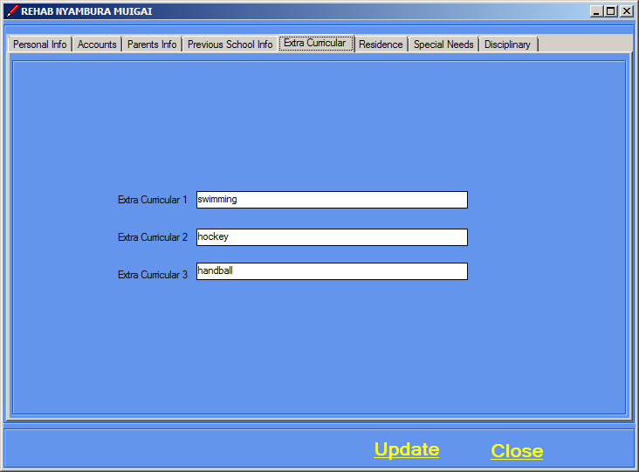
10. Add extra curricular activities.
11. Click on Residence tab,the screen below appears. 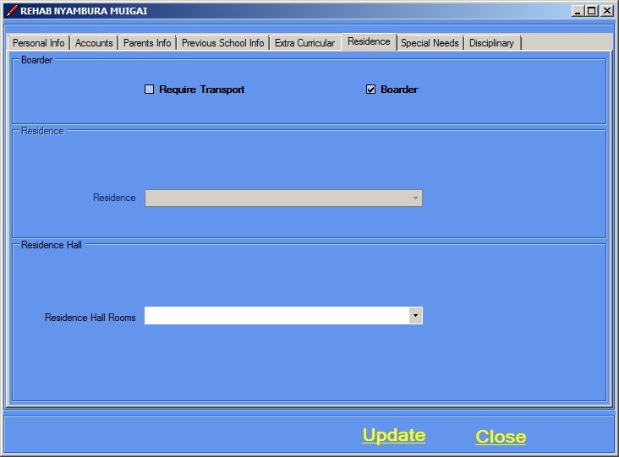
12. Add residence details.
13. Click on Special needs tab,the screen below appears. 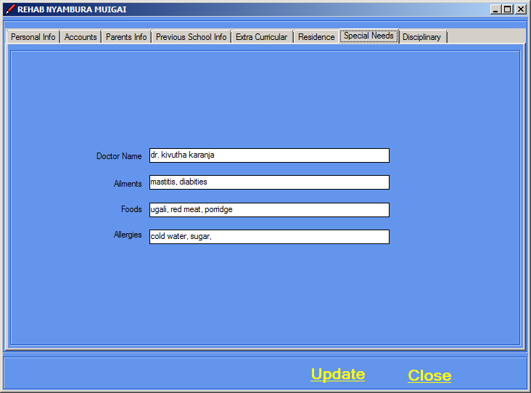
14. Add special needs details.
15. Click Disciplinary tab,the screen below appears. 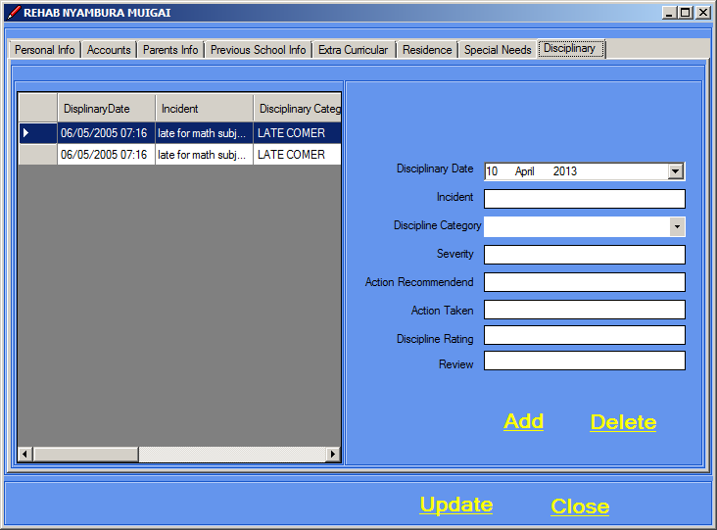
16. Add disciplinary details.
17. Click Update then Close.

# : How to delete a Student

1. To delete a student you must first delete the account associated with the student.
2. After deleting the accounts associated with it,Click Data Entry on the menu bar.
3. Click Students.
4. Select the Student you want to delete.
5. Click Delete.
6. The screen below will appear.

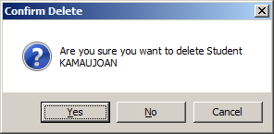

1. Confirm deletion by clicking Yes.

1.6. Customer

# How to add a Customer

1. Click Data Entry on the menu bar.
2. Click Customer s.
3. The screen shown below will appear.

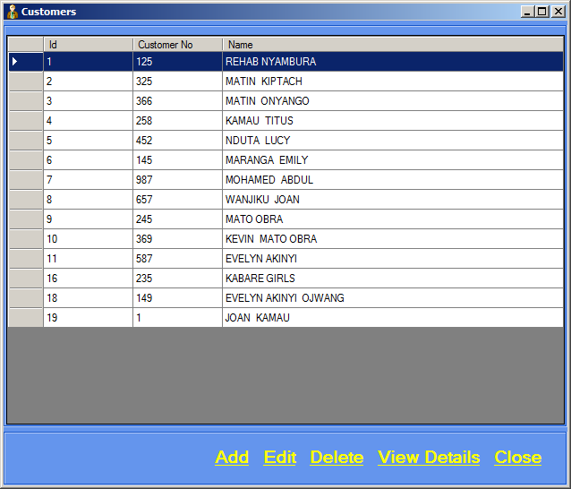4. Click on add, the screen below will appear. 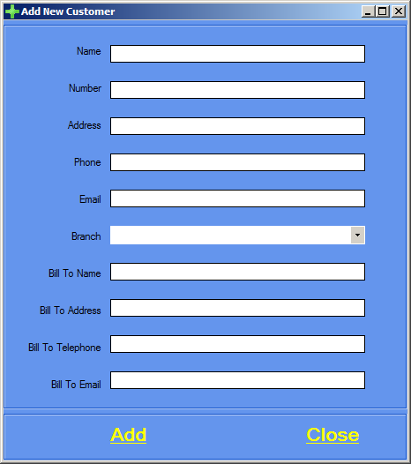

5. Type customer details and then click Add.

# : How to edit a Customer

1. Click Data Entry on the menu bar.
2. Click Customers.
3. Select the Customer you want to edit.
4. Click Edit, the screen below will appear. 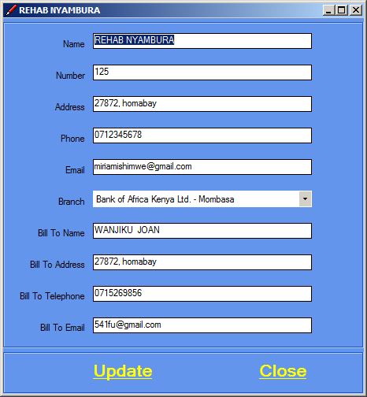
5. Edit Customer details.
6. Click Update then Close.

# : How to delete a Customer

1. Click Data Entry on the menu bar.
2. Click Customers.
3. Figure 14 will appear.
4. Select the Customer you want to delete.
5. Click delete, the screen below will appear.

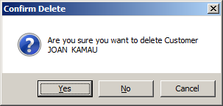

1. Confirm deletion by clicking Yes.
2. Click Close.

1.7. Parents

# : How to add a Parent

1. Click Data Entry on the menu bar.
2. Click Parents.
3. The screen shown below will appear. 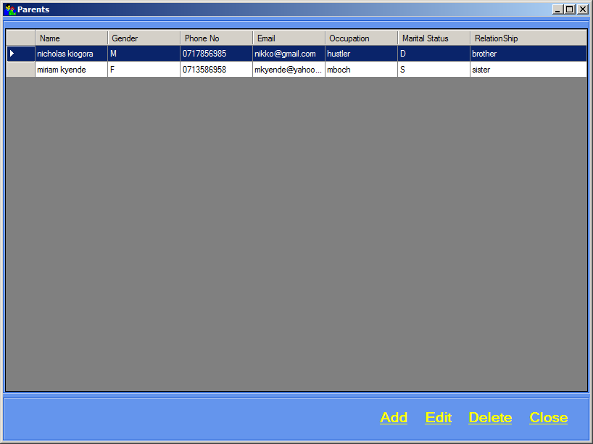
4. Click on Add,the screen below will appear. 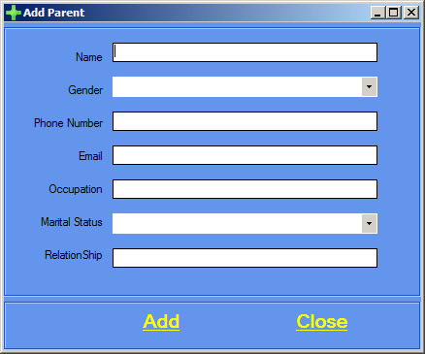
5. Add parent details.
6. Click Add then Close.

# : How to edit a Parent

1. Click Data Entry on the menu bar.
2. Click Parents.
3. Select the Parent you want to edit.
4. Click Edit, the screen below will appear. 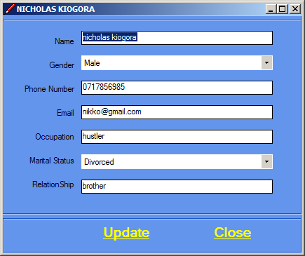
5. Edit parent details,click Update then Close

# : How to delete a Parent

1. Click Data Entry on the menu bar.
2. Click Parents.
3. Select the Parent you want to delete.
4. Click delete, the screen below will appear.

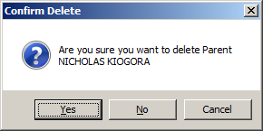

1. Confirm deletion by clicking Yes.
2. Click Close.

1.8. Timetable

# How to Enter Subjects in a Timetable

1. Click Data Entry on the menu bar.
2. Click Timetable.
3. The screen shown below will appear.

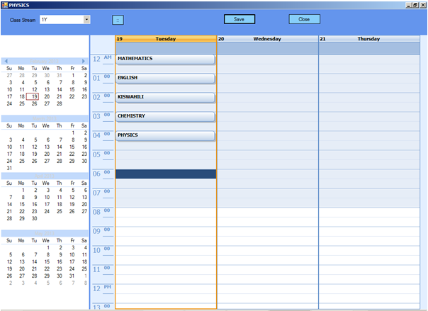

Figure Timetable Screen

1. Type in the Subjects by double clicking on the desired field.
2. Click Save then Close.

# : How to edit a timetable

1. Click Data Entry on the menu bar.
2. Click Timetable.
3. Figure 16 will appear.
4. Double click on the subject you want to edit.
5. Edit then click Save then Close.

# : How to delete a subject in a timetable

1. Click Data Entry on the menu bar.
2. Click Timetable.
3. Figure 16 will appear.
4. Click on the subject you want to delete.
5. Press Delete button.
6. Click Save then Close.
7. Alternatively, double click on the subject and delete.

1.9. Grading

# : How to add a Grading System

1. Click Data Entry on the menu bar.
2. Click Grading.
3. The screen shown below will appear.

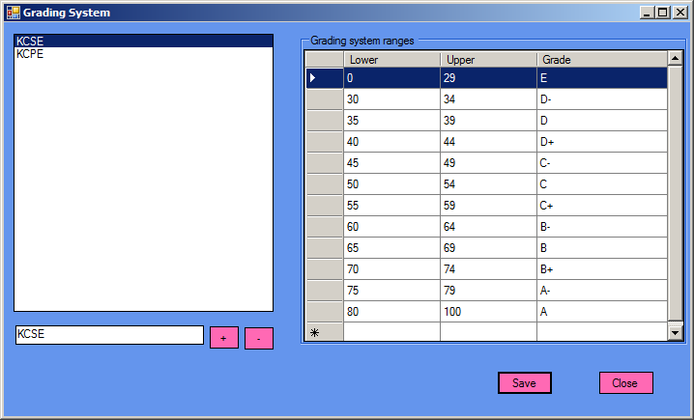4. Add a Grading system.

5. Then add its grading system ranges and grades.

5. Click Save then Close.

1.10. Attendance

# : How to add an Attendance

1. Click Data Entry on the menu bar.
2. Click Attendance.
3. The screen shown below will appear. 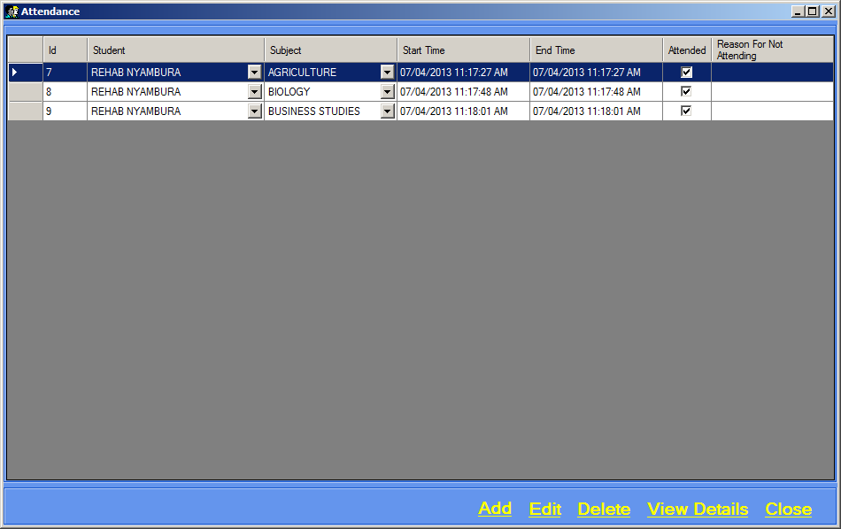
4. Click Add,the screen below will appear. 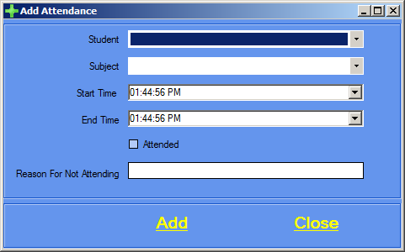
5. Student and subject are mandatory.
6. Click Add then Close.

# : How to edit an Attendance

1. Click Data Entry on the menu bar.
2. Click Attendance.
3. Select the attendance you want to edit.
4. Click edit, the screen below will appear.

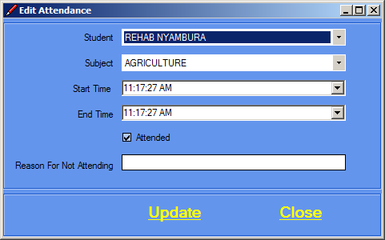

1. Edit attendance details.
2. Click Update then close.

# : How to delete an Attendance

1. Click Data Entry on the menu bar.
2. Click Attendance.
3. Select the Attendance you want to delete.
4. Click delete, the screen below will appear. 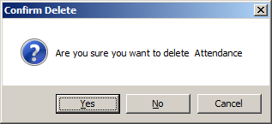

# : How to View Details of an Attendance

1. Click Data Entry on the menu bar.
2. Click Attendance.
3. Select the Attendance you want to view.
4. Click View details. The screen below will appear.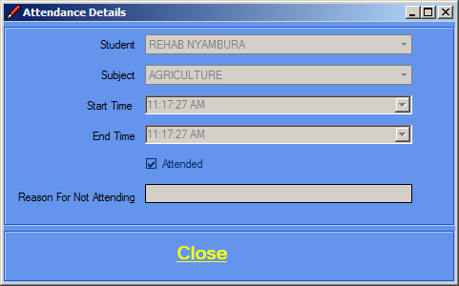
5. Click Close after viewing attendance details.

1.11. Room

# : How to add a Room

1. Click Data Entry on the menu bar.
2. Click Rooms.
3. The screen shown below will appear.

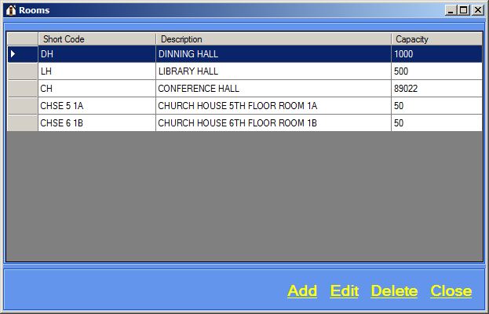

1. Click Add, a screen will appear as shown below.

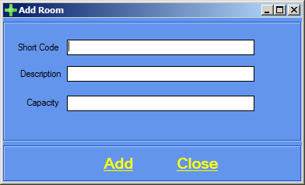

1. Type in the room details, click Add then Close.

# : How to edit a Room

1. Click Data Entry on the menu bar.
2. Click Rooms.
3. Select the Room you want to edit.
4. Click Edit, the screen below will appear.

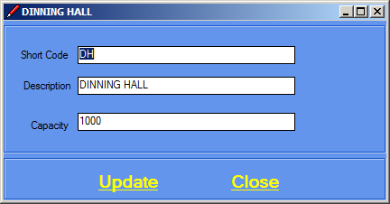

1. Edit Room details.
2. Click Update then Close.

# : How to delete a Room

1. Click Data Entry on the menu bar.
2. Click Rooms.
3. Select the Student you want to delete.
4. Click delete, the screen below will appear.

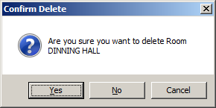

1. Confirm deletion by clicking Yes.
2. Click Close.
   1. Disciplinary Categories

# : How to add a Disciplinary Category

1. Click Data Entry on the menu bar.
2. Click Disciplinary Categories.
3. The screen shown below will appear. 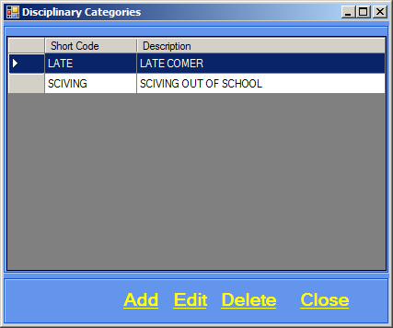
4. Click Add,the screen below will appear. 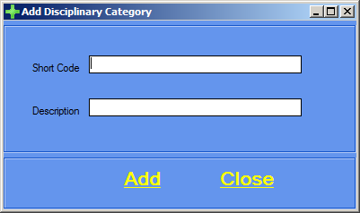
5. Type in disciplinary category details.
6. Click Add then Close.

# : How to edit a Disciplinary Category

1. Click Data Entry on the menu bar.
2. Click Disciplinary Categories.
3. Select the disciplinary category you want to edit.
4. Click Edit, the screen below will appear. 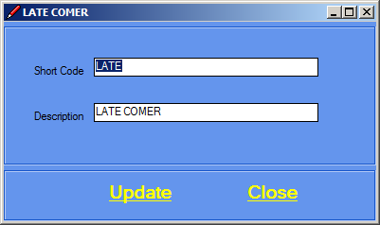
5. Edit details.
6. Click Update then Close.

# : How to delete a Disciplinary Category

1. You must first delete Disciplines associated with a Discipline Category before deleting it.
2. After deleting the Disciplines associated with a Discipline Category, Click Data Entry on the menu bar.
3. Click Disciplinary Categories.
4. Select the Discipline Category you want to delete.
5. Click delete, the screen below will appear.

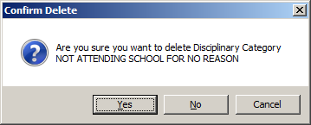

1. Confirm deletion by clicking Yes.
2. Click close.
   1. Residence

# : How to add a Residence

1. Click Data Entry on the menu bar.
2. Click Residence.
3. The screen shown below will appear. 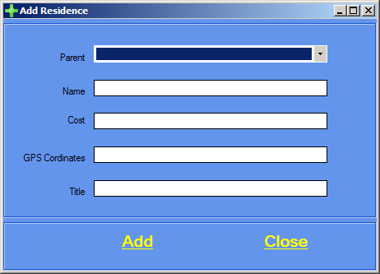
4. Select a parent.
5. Type in residence details.
6. Click Add then Close.

# : How to edit a Residence

1. Click Data Entry on the menu bar.
2. Click Residence.
3. Select the Residence you want to edit.
4. Click edit, the screen below will appear. 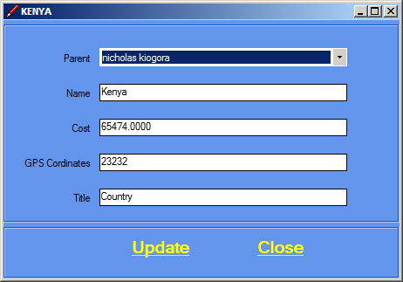
5. Edit residence details.
6. Click Update then Close.

# : How to delete a Residence

1. Click Data Entry on the menu bar.
2. Click Residence.
3. Select the Residence you want to delete.
4. Click delete, the screen below will appear. 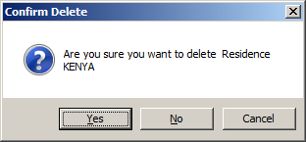
5. Confirm deletion by clicking Yes.
6. Click Close.
   1. Residence Hall

# : How to add a Residence Hall

1. Click Data Entry on the menu bar.
2. Click Residence Halls.
3. The screen shown below will appear.

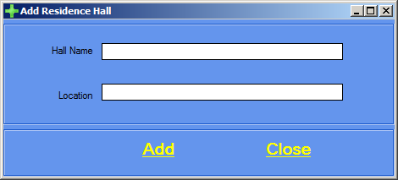

1. Add Hall details.
2. Click Add then Close.

# : How to edit aResidence Hall

1. Click Data Entry on the menu bar.
2. Click Residence Halls.
3. Select the Residence Hall you want to edit.
4. Click edit, the screen below will appear. 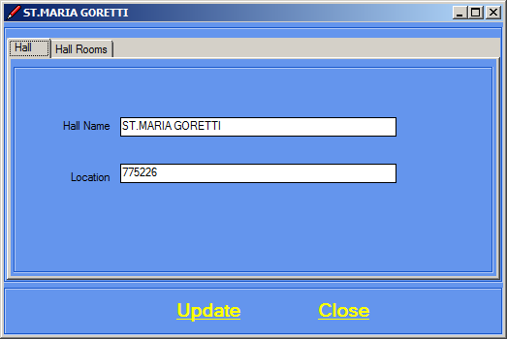
5. Edit hall details then Click on Hall Rooms tab,the screen below appears.

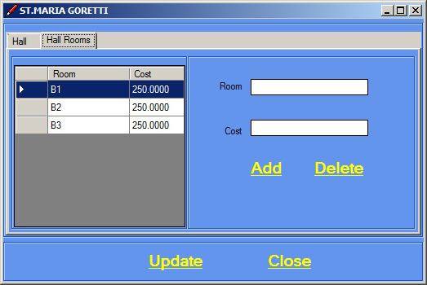

1. To add a hall room type in room and cost and click Add.
2. To delete a hall room, select the hall room and click Delete.

# : How to delete aResidence Hall

1. Click Data Entry on the menu bar.
2. Click Residence Halls.
3. Select the Residence Hall you want to delete.
4. Click delete, the screen below will appear.

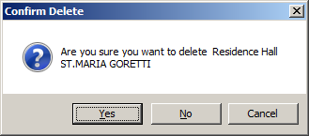

1. Confirm deletion by clicking Yes.
2. Click Close.
   1. Transport

# : How to add Transport cost for a particular area

1. Click Data Entry on the menu bar.
2. Click Transport.
3. The screen shown below will appear. 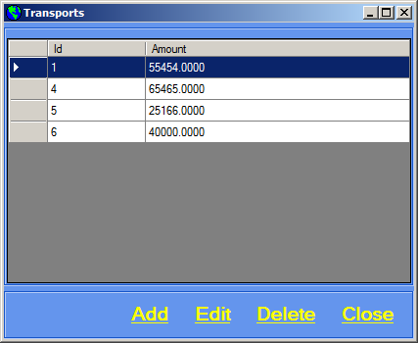
4. Click Add,the screen below appears. 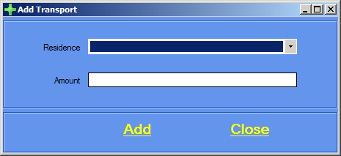
5. Type in Transport details.
6. Click Add then Close.

# : How to edit Transport cost for a particular area

1. Click Data Entry on the menu bar.
2. Click Transport.
3. Select the Transport cost you want to edit.
4. Click edit, the screen below will appear. 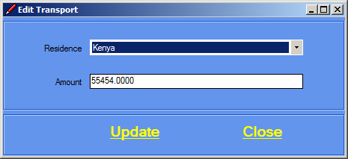
5. Edit transport details.
6. Click Update then Close.

# : How to delete Transport cost for a particular area

1. Click Data Entry on the menu bar.
2. Click Transport.
3. Select the Transport cost you want to delete.
4. Click delete, the screen below will appear. 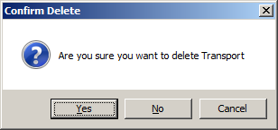
5. Confirm deletion by clicking Yes.
6. Click Close.

EXAMS

* 1. Exams

1. Click Exams on the menu bar.
2. Click Exams.
3. The screen shown below will appear. 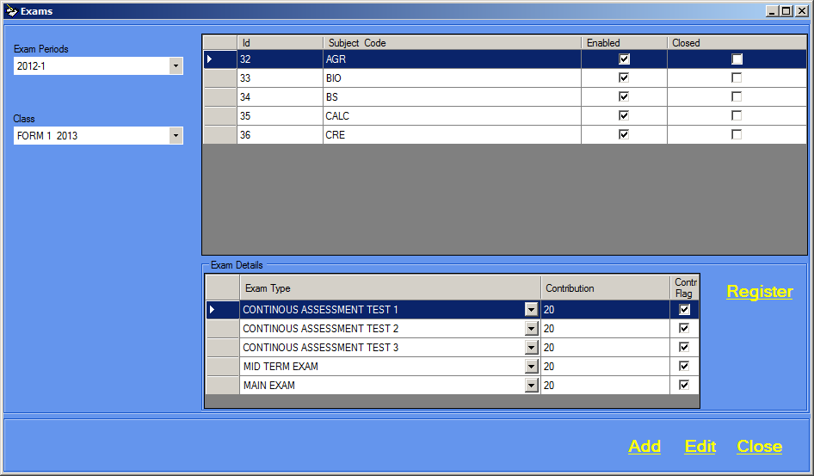
4. Click Add, the screen below will appear. 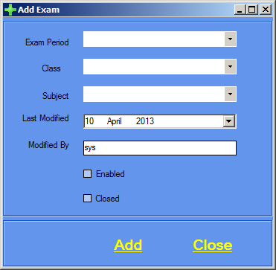
5. Exam period, Class and Subject are mandatory.
6. Click Add then close.

**Registering an Exam**

1. To register an exam, Click Exams on the menu bar.
2. Click Exams.
3. The screen shown below will appear. 
4. Select the exam you want to register.
5. Click Register,the screen below will appear. 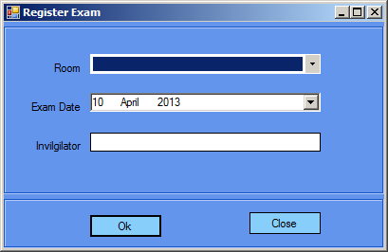
6. Type in the details.
7. Click Ok then Close.

# : How to edit an Exam

1. Click Data Entry on the menu bar.
2. Click Exams.
3. Select the Exam you want to edit.
4. Click edit, the screen below will appear. 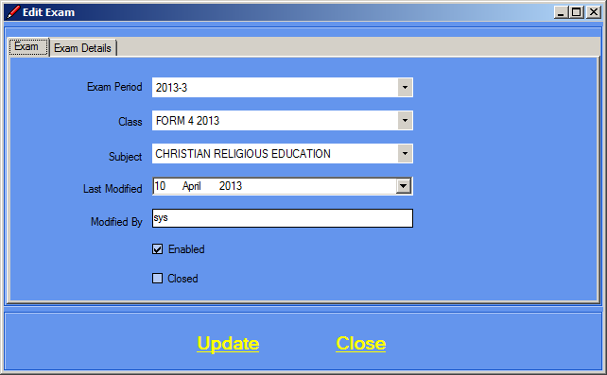
5. Edit details,then Click on Exam Details tab, the screen below will appear.

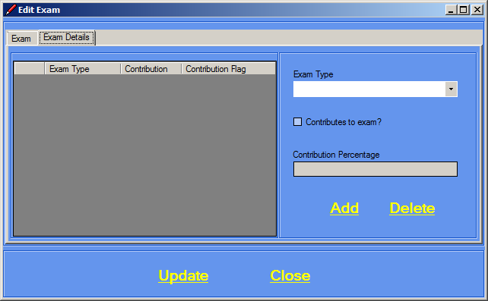

1. Add exam type details add click Add.
2. To delete exam type details,select the exam type that you want to delete.
3. Click Delete.
4. Click Update then Close.

1.2. Exam Types

# : How to add an Exam Type

1. Click Exams on the menu bar.
2. Click Exam Types.
3. The screen shown below will appear.

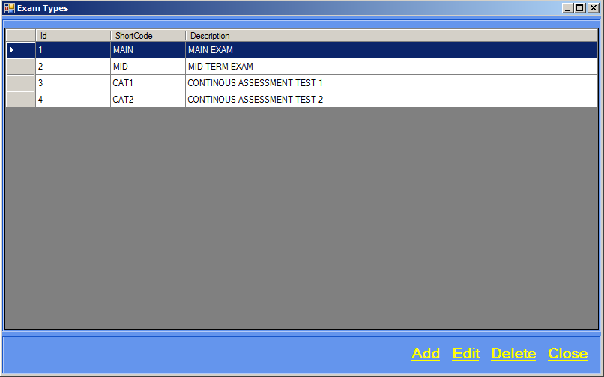

1. Click Add, a screen will appear as shown below.

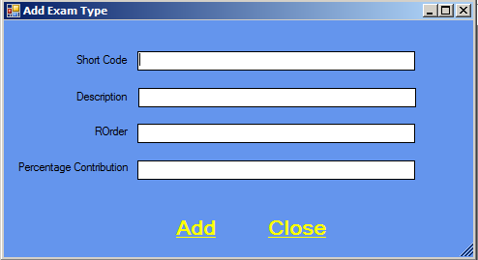

1. Type in the Exam Type details.
2. Click Add then Close.

# : How to edit an Exam Type

1. Click Exams on the menu bar.
2. Click Exam Types.
3. Select the exam type you want to edit and click Edit. See example below.

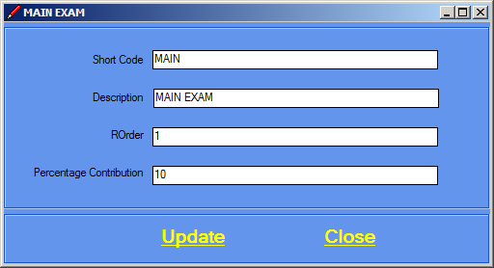

1. Edit exam type details.
2. Click Update then Close.

# How to delete an Exam Type

1. Click Exams on the menu bar.
2. Click Exam Types.
3. Select the exam type you want to delete and click Delete. The screen below will appear.

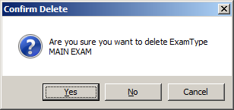

1. Confirm deletion by clicking Yes.
2. Click Close.

1.3. Exam Periods

# : How to add an Exam Period

1. Click Exams on the menu bar.
2. Click Exam Periods.
3. The screen shown below will appear.

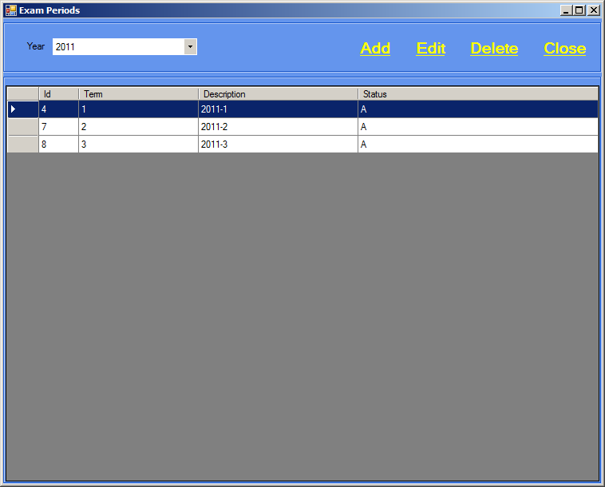

1. Click Add, a screen will appear as shown below.

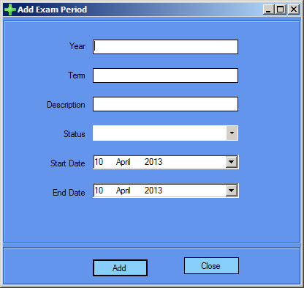

1. Add Exam Period details.
2. Click Add then Close.

# : How to edit an Exam Period

1. Click Exams on the menu bar.
2. Click Exam Periods.
3. Select the Exam Period you want to edit and click Edit. See example below. 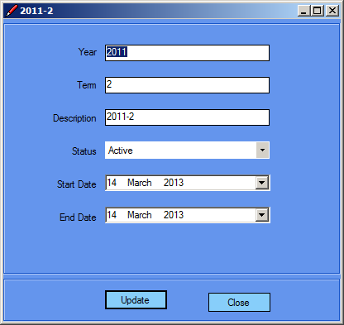
4. Edit Exam Period details.
5. Click Update then Close.

# : How to delete an Exam Period

1. Click Exams on the menu bar.
2. Click Exam Periods.
3. Select the Exam Period you want to delete and click Delete. The screen below will appear.
4. 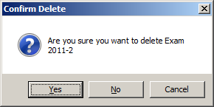Confirm deletion by clicking Yes.
5. Click Close.

1.4. Register Students

# : How to Register a Student

1. Click Exams on the menu bar.
2. Click Register Students.
3. The screen shown below will appear.

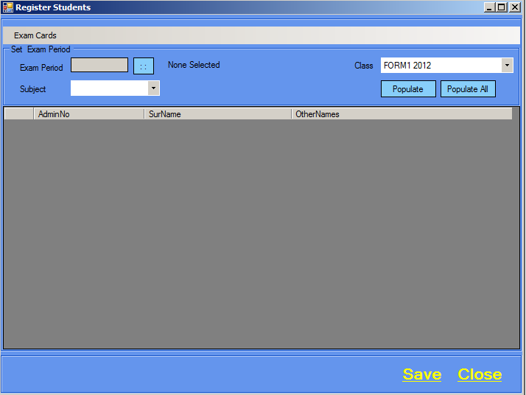

1. Click the search button next to Exam Period, the screen below will appear.

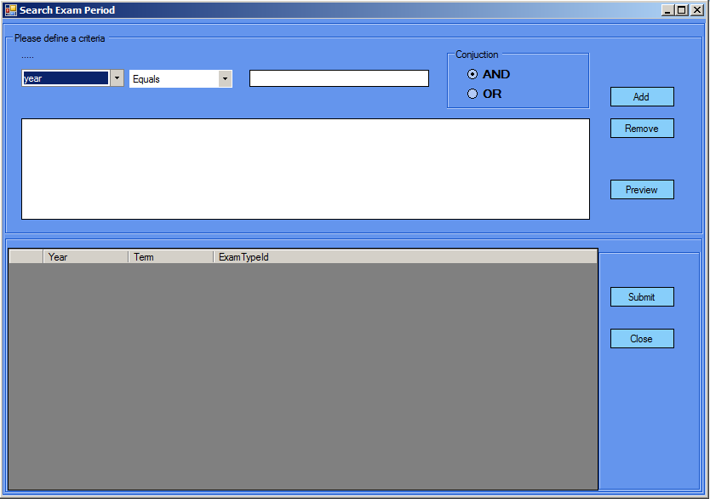

1. Define a criteria then Click Add.
2. Click Preview then select an Exam Period.
3. Click Submit.
4. A screen with a list of Students will appear, see example below.

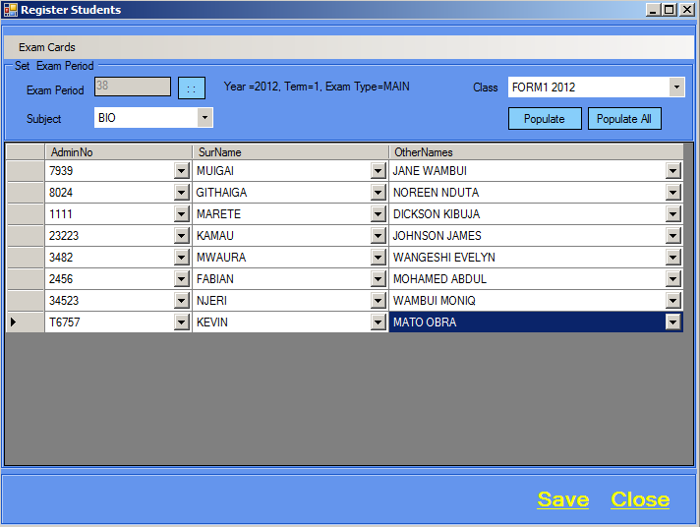

1. Select the subject being examined and the class doing the exam.
2. Choose the students being registered for the exam.
3. Click Populate.
4. Click Save then Close.
5. If all students are being registered for the exam click Populate then click Save then Close.

1.5. Mark Sheet

# : How to add a Mark Sheet

1. Click Exams on the menu bar.
2. Click Mark Sheet.
3. The screen shown below will appear.

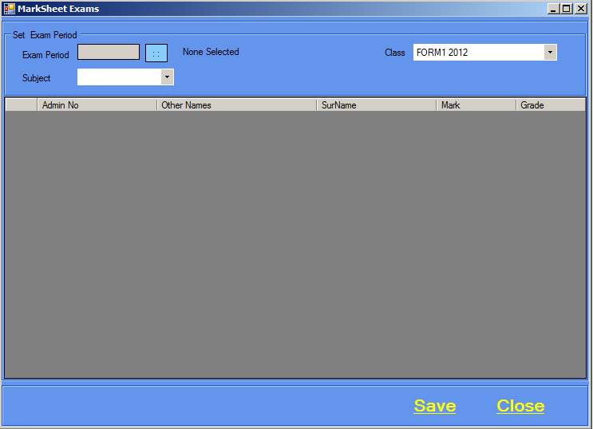

1.6. Process Exams

# : How to Process Exams

1. Click Exams on the menu bar.
2. Click Process Exams.
3. The screen shown below will appear.

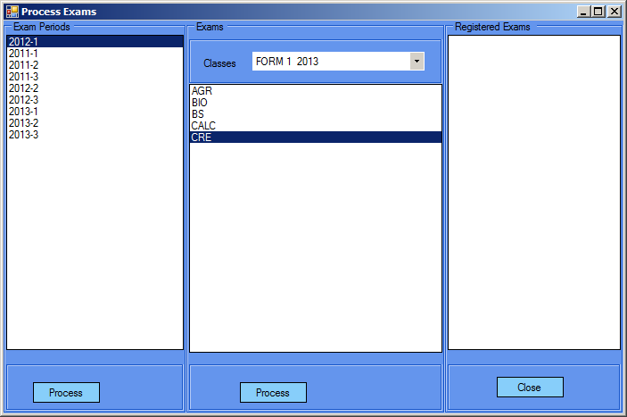

1. Select the year and term.
2. Click Process exam then Close.

FEES

* 1. Fee Structure

# : How to add a Fee Structure

1. Click Fees on the menu bar.
2. Click Fee Structure.
3. The screen shown below will appear. 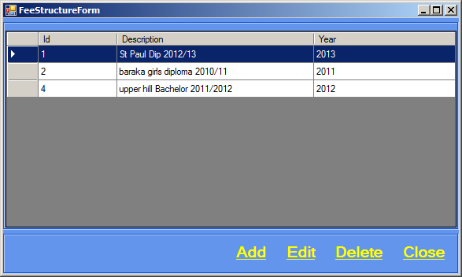
4. Click Add,the screen below will appear.

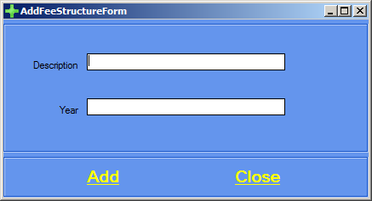

1. Type in fee structure details.
2. Click Add then Close.

# : How to edit a Fee Structure

1. Click Fees on the menu bar.
2. Click Fee Structure.
3. Select the Fee Structure you want to edit and click Edit. See example below. 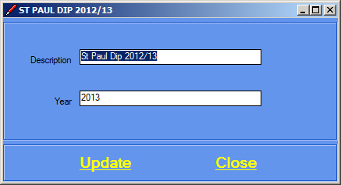
4. Edit Fee Structure details.
5. Click Update then Close.

# : How to delete a Fee Structure

1. You must first delete Fee Structure Academic that are associated with a Fee Structure before you delete it.
2. Click Fees on the menu bar.
3. Click Fee Structure.
4. Select the Fee Structure you want to delete and click Delete. The screen below will appear. 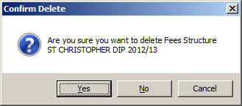
5. Confirm deletion by clicking Yes
6. Click Close.
   1. Fee Structure Academic

# : How to add a Fee Structure

1. Click Fees on the menu bar.
2. Click Fee Structure Academic.
3. The screen shown below will appear. 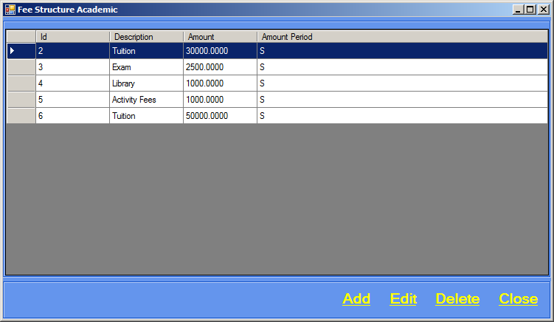
4. Click Add,the screen below will appear. 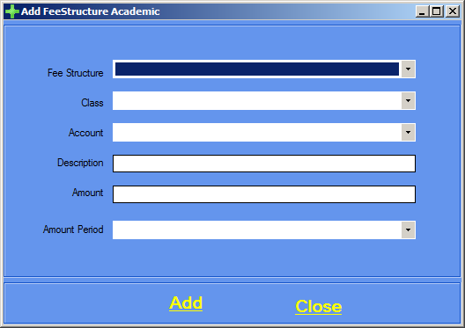
5. Type in Fees structure details.
6. Click Add then Close.

# : How to edit a Fee Structure

1. Click Fees on the menu bar.
2. Click Fee Structure Academic.
3. Select the Fee Structure you want to edit and click Edit. See example below. 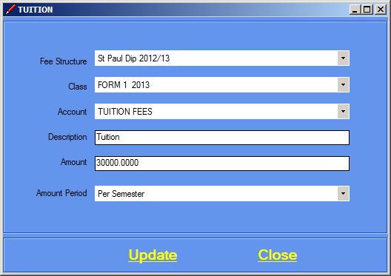
4. Edit Fee Structure details.
5. Click Update then Close.

# : How to delete a Fee Structure

1. Click Fees on the menu bar.
2. Click Fee Structure Academic.
3. Select the Fee Structure you want to delete and click Delete. The screen below will appear. 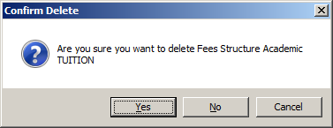
4. Confirm deletion by clicking Yes.
5. Click Close.
   1. Fee Structure Others

# : How to add a Fee Structure

1. Click Fees on the menu bar.
2. Click Fee Structure Others.
3. The screen shown below will appear. 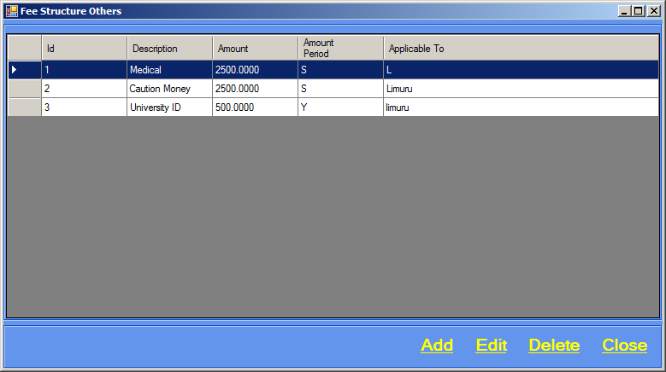
4. Click Add,the screen below will appear.

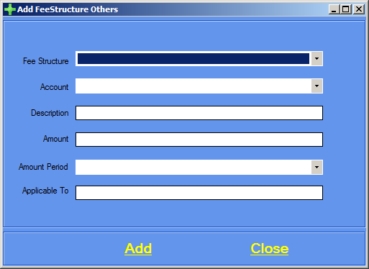

1. Type in Fees structure details.
2. Click Add then Close.

# : How to edit a Fee Structure

1. Click Fees on the menu bar.
2. Click Fee Structure Others.
3. Select the Fee Structure you want to edit and click Edit. See example below. 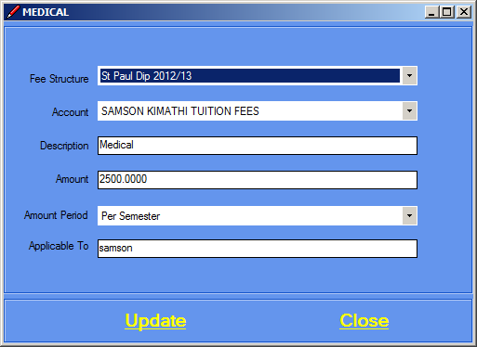
4. Edit Fee Structure details.
5. Click Update then Close.

# : How to delete a Fee Structure

1. Click Fees on the menu bar.
2. Click Fee Structure Others.
3. Select the Fee Structure you want to delete and click Delete. The screen below will appear. 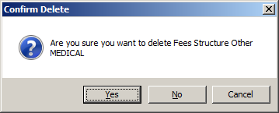
4. Confirm deletion by clicking Yes.
5. Click Close.
   1. Admission

**Student**

# : How to Admit a Student

1. Click Admission on the menu bar.
2. You can then type in the student’s admission number and click retrieve, alternatively if you do not know students admission number you can opt to search for it by clicking on Students tab, the screen shown below will appear. 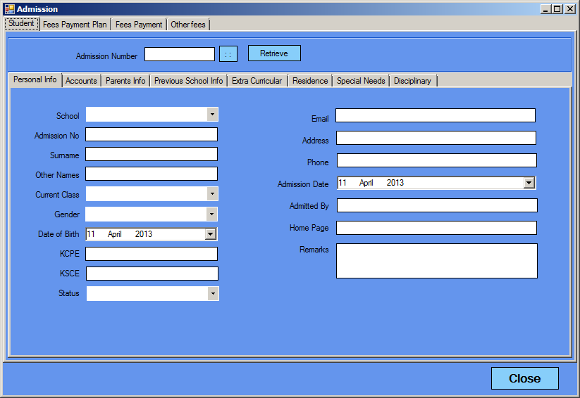
3. Click the Search button, the screen below will appear. 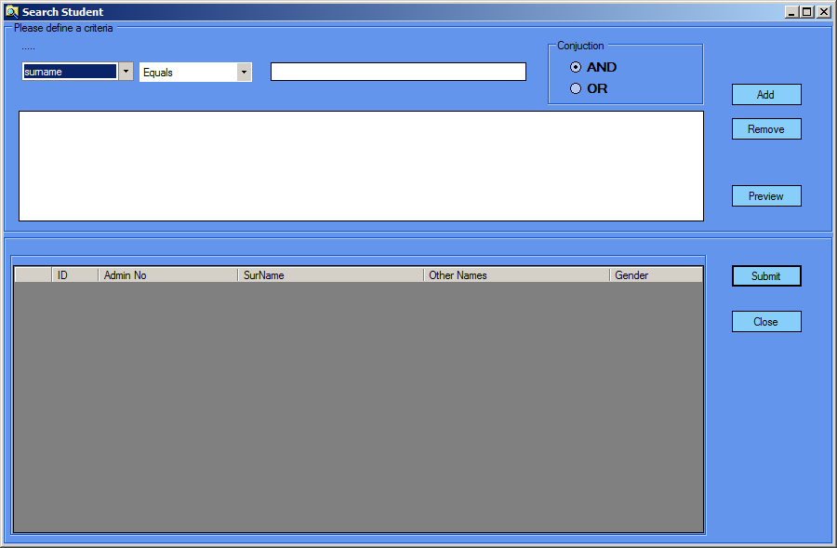
4. Define criteria for searching a student by selecting you preferred choices from the combo boxes.
5. After defining a criteria, click Add. The search results will be displayed as shown in the example below. 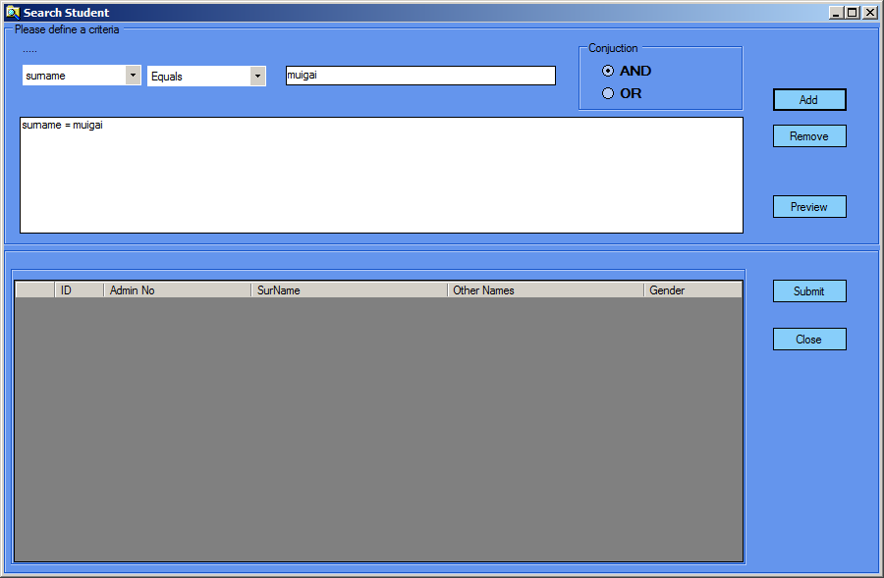
6. Select the student you want and click Preview,as shown in the figure below. 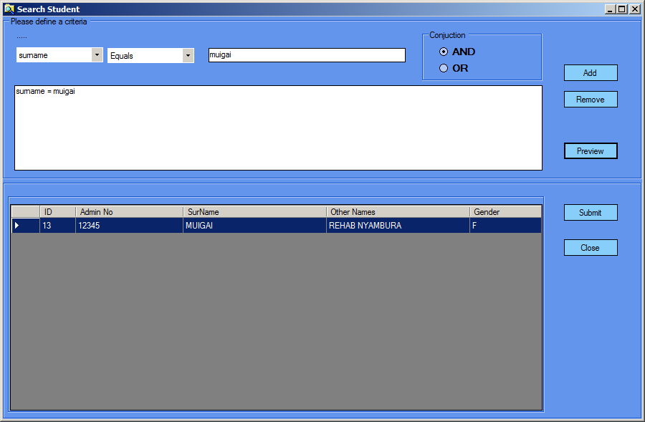
7. Click Submit and the system will automatically input the student’s admission number.
8. Click on retrieve to get student’s information, as shown in the example below. 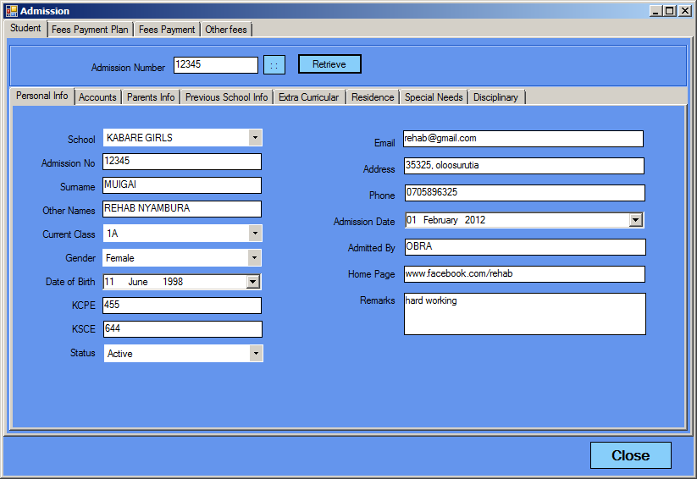

**Fees Payment Plan**

1. After getting student’s information, click on Fees Payment Plan tab, the screen below will appear. 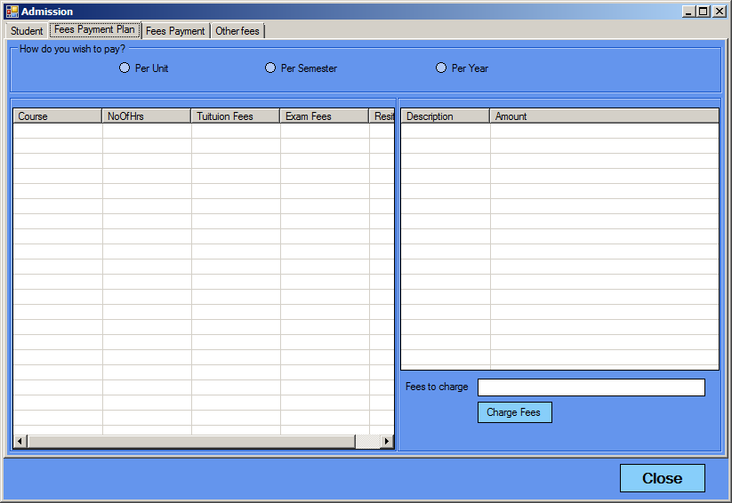
2. Choose the option that the student will pay by. If the student will opt to pay per unit,select Per Unit,as shown in example below. 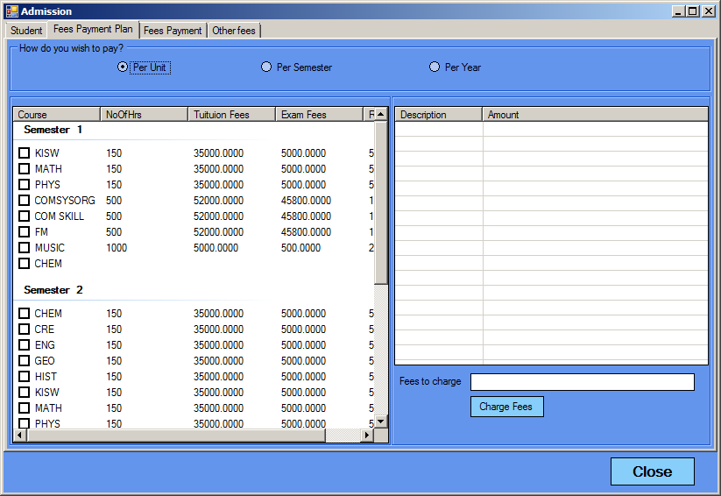
3. Proceed by selecting which subjects the student is paying for.Notice that for each subject you select the corresponding payments are displayed. See example below. 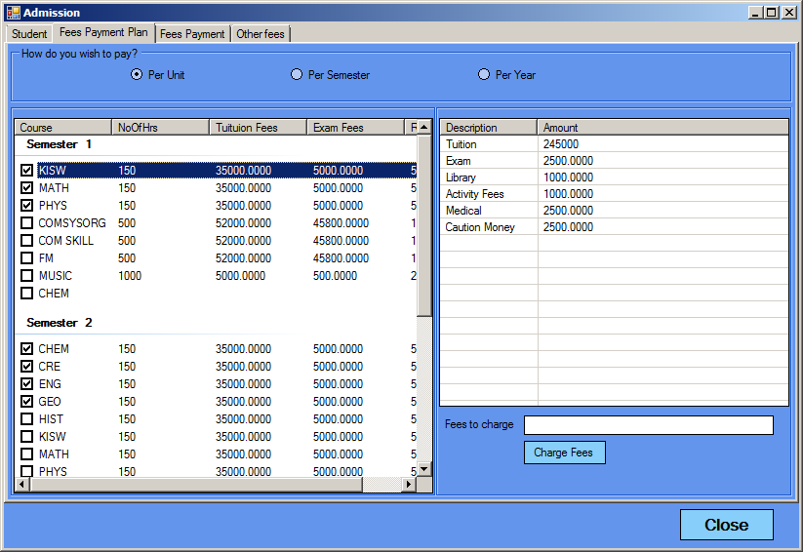
4. To know the total fees amount to be paid click on Charge Fees and the total amount will be summed up and shown. See example below. 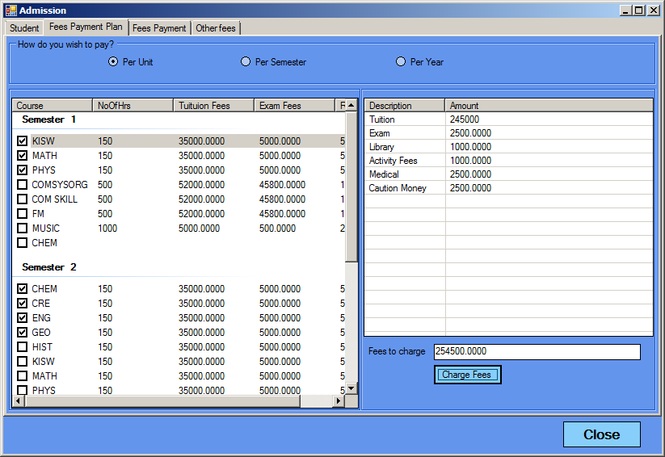

**Fees Payment**

1. After choosing a fee payment plan, click on Fees Payment tab, the screen below will appear. 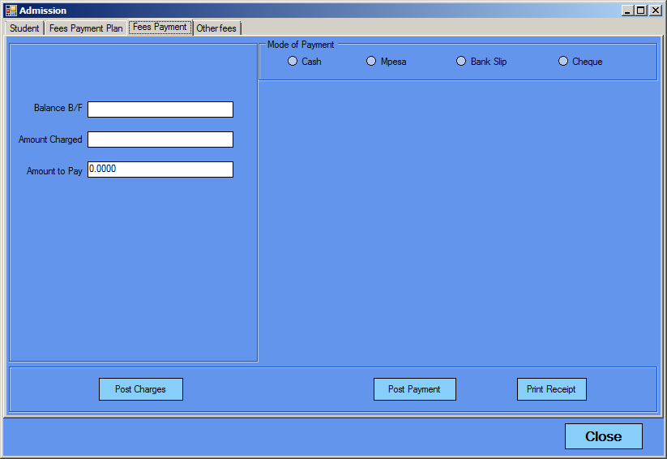
2. You can then type the balance,amount charged and amount to pay and then post charges.
3. Choose mode of payment and post payment.

16. You can as well print a receipt.

**Other Fees**

* 1. Fee Posting (Single)

1. Click Fees on the menu bar.
2. From Fee Posting, select Single.
3. The screen shown below will appear.

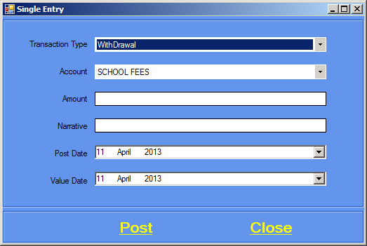

1. Transaction type, Account, Amount and Narrative are mandatory.
2. Click Post and a message box will appear as shown below.

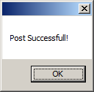

1. Click OK.
   1. Fee Posting (Double)
2. Click Fees on the menu bar.
3. From Fee Posting, select Double.
4. The screen shown below will appear. 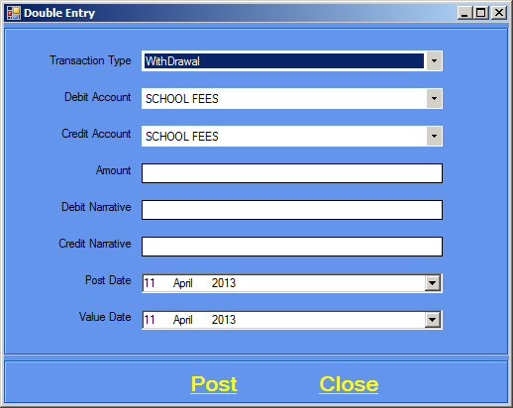
5. Transaction type, Debit Account, Credit Account, Amount, Debit Narrative and Credit Narrative are mandatory.
6. Click Post and a message box will appear as shown below.
7. Click Ok.
   1. Fee Posting (Multiple)
8. Click Fees on the menu bar.
9. From Fee Posting, select Multiple.
10. The screen shown below will appear.

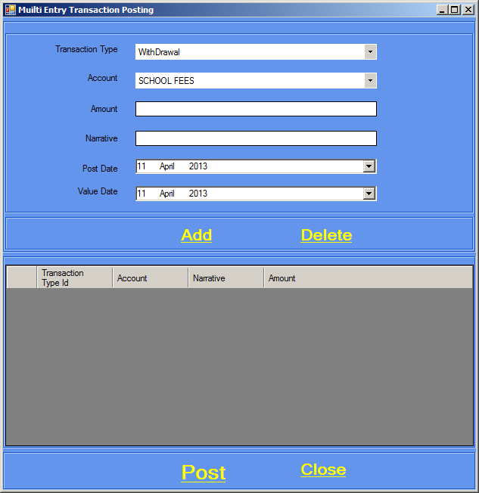

1. Transaction type, Account, Amount and Narrative are mandatory.
2. The fee posted will be displayed, see example below. 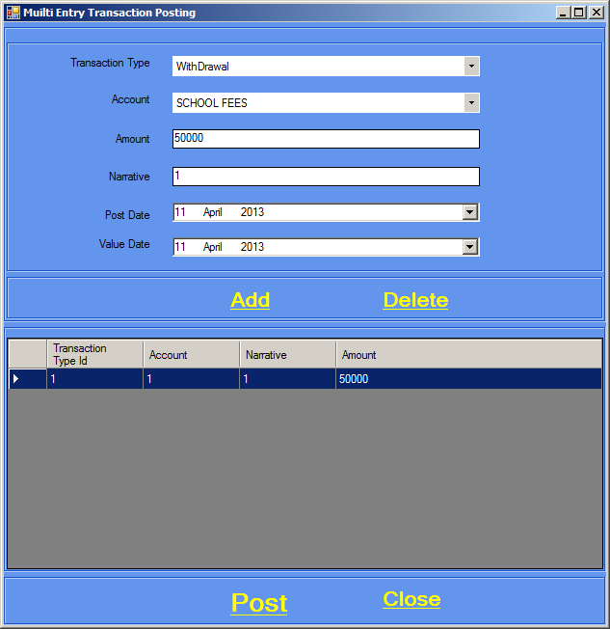
3. Click Close after you’ve finished.

TRANSACTIONS

* 1. Accounts

# : How to add an Account

1. Click Transactions on the menu bar.
2. Click Accounts.
3. The screen shown below will appear.

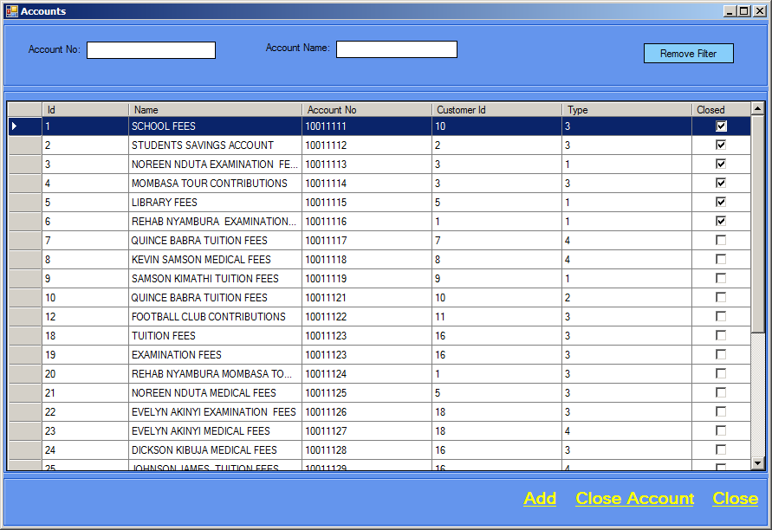

1. Click Add, the screen below will appear.

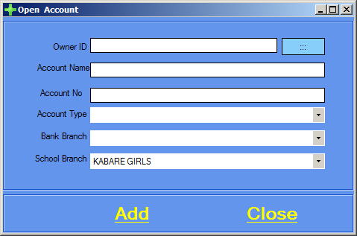

1. Type in the Account details.
2. Click Add then Close.

# : How to close an Account

1. Click Transactions on the menu bar.
2. Click Accounts.
3. Select the account you want to close and click Close Account.

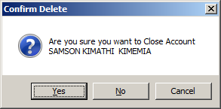

1. Confirm deletion by clicking Yes.
2. Click Close.
   1. Account Types

# : How to add an Account Type

1. Click Transactions on the menu bar.
2. Click Account Types.
3. The screen shown below will appear.

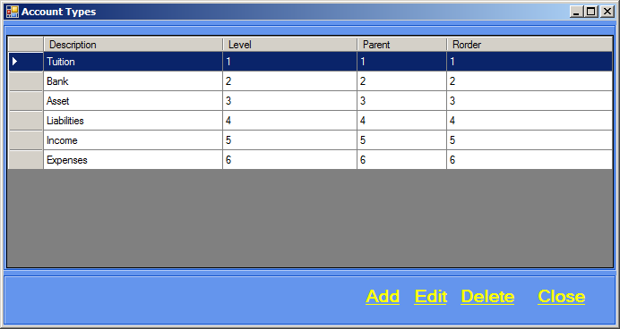

1. Click Add, the screen below will appear.

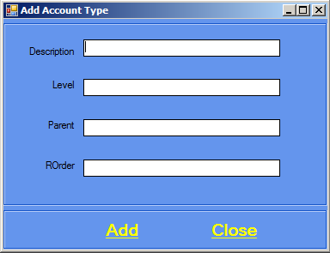

1. Type in the Account Type details.
2. Click Add then Close.

# : How to edit an Account Type

1. Click Transactions on the menu bar.
2. Click Account Types.
3. Select the account type you want edit.
4. Click edit. The screen below will appear.

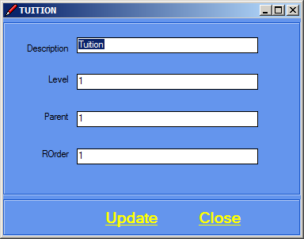

1. Edit account type details.
2. Click Update then Close.

# : How to delete an Account Type

1. Click Transactions on the menu bar.
2. Click Account Types.
3. Select the account type you want delete.
4. Click delete.

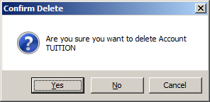

1. Confirm deletion by clicking Yes.
   1. Transaction Types

# : How to add a Transaction Type

1. Click Transactions on the menu bar.
2. Click Transaction Types.
3. The screen shown below will appear.

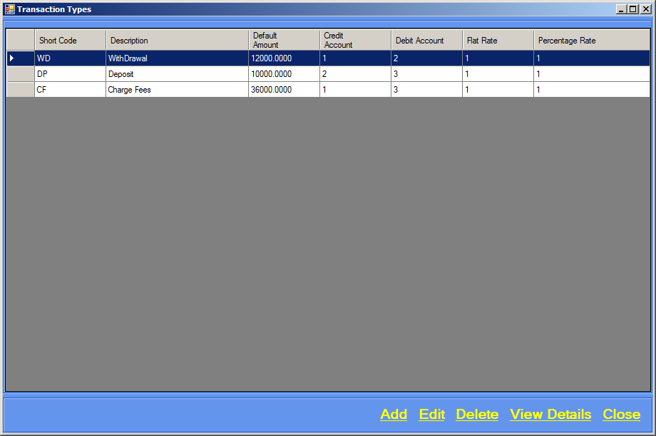

1. Click Add, a screen will appear as shown below.

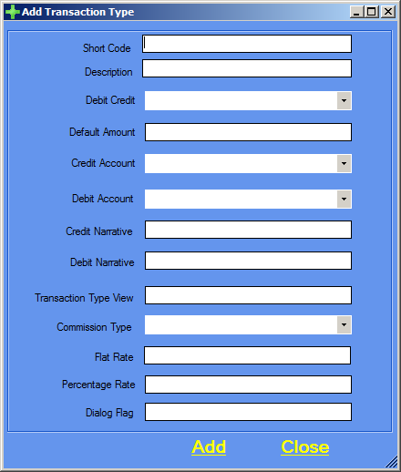

1. Type in the Transaction Type details.
2. Click Add then Close.

# : How to edit a Transaction Type

1. Click Transactions on the menu bar.
2. Click Transaction Types.
3. Select the transaction type you want to edit.
4. Click Edit. See example below.

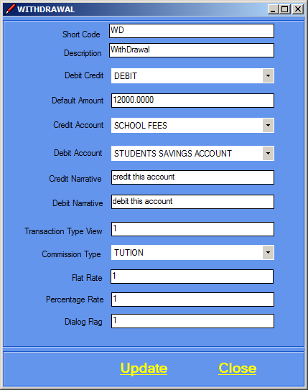

1. Edit the transaction type details.
2. Click Update then Close.

# : How to delete a Transaction Type

1. Click Transactions on the menu bar.
2. Click Transaction Types.
3. Select the transaction type you want to delete.
4. Click delete.

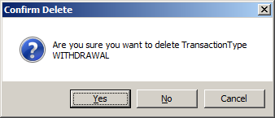

1. Confirm deletion by clicking Yes.
2. Click Close.

# : How to view a Transaction Type details

1. Click Transactions on the menu bar.
2. Click Transaction Types.
3. Select the transaction type you want to view.
4. Click View Details. See example below.

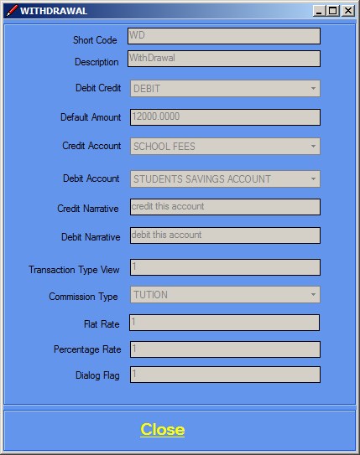

1. Click Close.
   1. Banks

# : How to add a Bank

1. Click Transactions on the menu bar.
2. Click Banks, the screen below will appear. 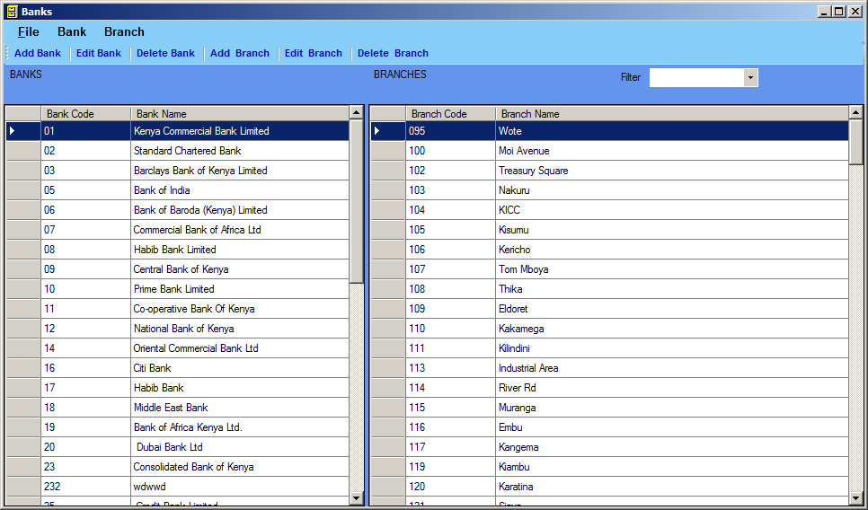
3. Click Add Bank, the screen below will appear. 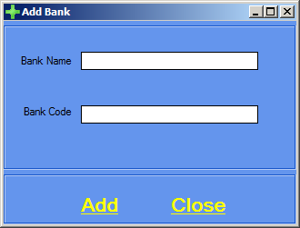
4. Type Bank details then click Add.

# : How to edit a Bank

1. Click Transactions on the menu bar.
2. Click Banks.
3. Select the bank you want to edit then click Edit, the screen below will appear. 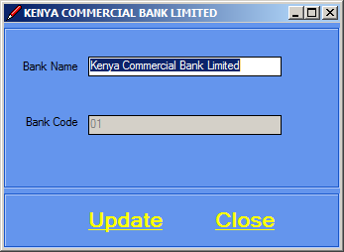
4. Edit Bank details then click Update.

# : How to delete a Bank

1. Click Transactions on the menu bar.
2. Click Banks.
3. Select the bank you want to delete then click Delete, the screen below will appear. 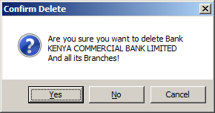
4. Confirm deletion by clicking Yes.

**Branch**

# : How to add a Branch

1. Click Transactions on the menu bar.
2. Click Banks, the screen below will appear. 
3. Select the Bank that you want to add a branch to.
4. Click Add Branch, the screen below will appear. 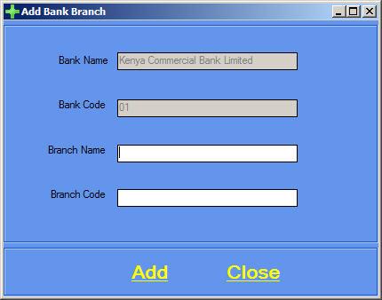
5. Type Bank details then click Add.

# : How to edit a Branch

1. Click Transactions on the menu bar.
2. Click Banks.
3. Select the bank associated with the branch that you want to edit.
4. Select the branch you want to edit and click Edit Branch, the screen below will appear. 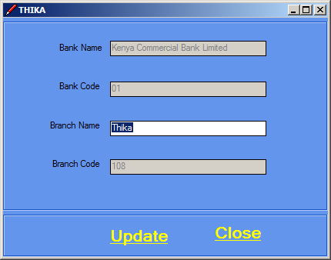
5. Edit branch details then click Update.

# : How to delete a Branch

1. Click Transactions on the menu bar.
2. Click Banks.
3. Select the bank associated with the branch that you want to delete.
4. Select the branch you want to delete and click Delete Branch, the screen below will appear.
5. 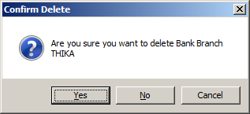Confirm deletion by clicking Yes.
   1. Enquiry

# : How to enquire about transaction list of an Account

1. Click Transactions on the menu bar.
2. Click Enquiry.
3. The screen shown below will appear.

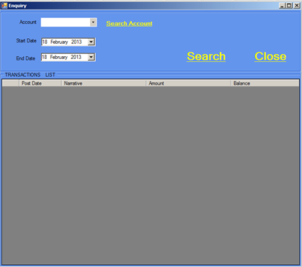

1. Search the account you want.
2. A transaction list will appear on the data grid.
3. Click close after viewing.
4. Alternatively, you can click on Enquiry
5. The screen below will appear.

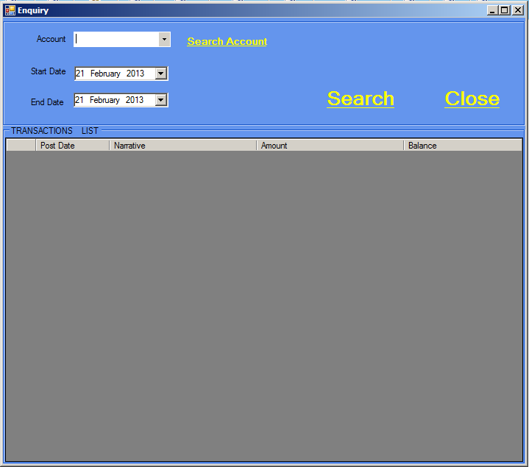

1. Search the account you want.
2. A transaction list will appear on the data grid.
3. Click close after viewing.

REPORTS

To view reports. Click Reports on the menu bar. The screen below will appear. 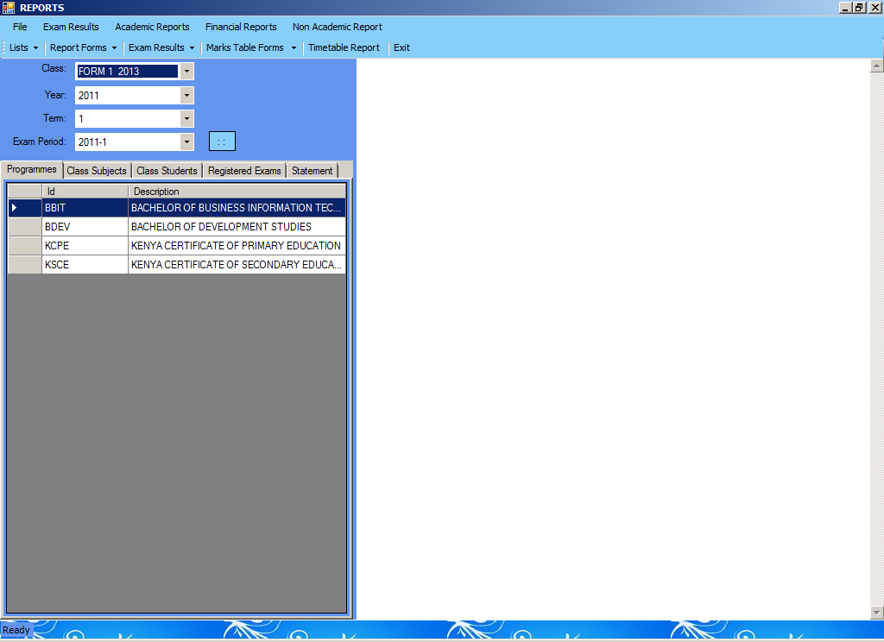

File

* 1. Students List
  2. Teachers List
  3. Subjects List
  4. Classes List
  5. Programme Courses List
  6. Exit

Exam Results

* 1. By Class
  2. By Class By Subject
  3. By Class By Subject By Exam Type
  4. Marks Table Form (Pre-School)
  5. Marks Table Form (Primary)
  6. Marks Table Form (Secondary)
  7. Marks Table Form (Tertiary)
  8. Marks Table Form (College)
  9. Marks Table Form (University)

Academic Reports

* 1. Student (Report Form)
  2. Student (Progress Form)
  3. Student (Student Performance By Target)
  4. Teacher (Report Form)
  5. Teacher (Progress Form)
  6. Teacher (Teacher Performance By Target)
  7. Class (Report Form)
  8. Class (Progress Form)
  9. Class (Student Performance By Target)
  10. Class (Class Consolidated Mark Sheet)
  11. School (Report Form)
  12. School (Progress Form)
  13. School(Student Performance By Target)
  14. School(Student Performance In The Region)

Financial Reports

* 1. Student
     1. Student statement
     2. Student Account status
     3. Arrears / Receivables
     4. Parent statement
     5. Parent Account status
     6. Payment receipts
     7. Fees structure
  2. School
     1. General Ledger
     2. PL
     3. BS
     4. Bank Statement
     5. CashBook
     6. Arrears / Receivables
     7. Payables
  3. Fees Structure
     1. By class
     2. By Programme
     3. By Account Types

Non Academic Reports

* 1. Student
     1. Discipline Status
     2. Disciplinary Record
     3. Extra curricula
     4. Medical record
     5. Attendance record

ADMINISTRATOR

* 1. School Set-up

# : How to add a School

1. Click Administrator on the menu bar.
2. Click School Set-Up.
3. The screen shown below will appear.

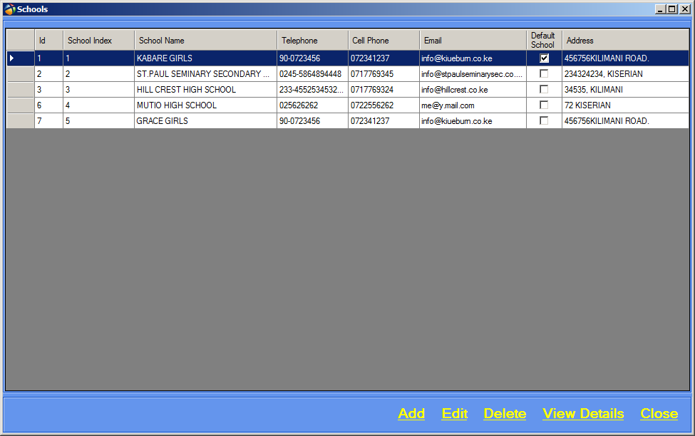

1. Click Add, the screen below will appear.

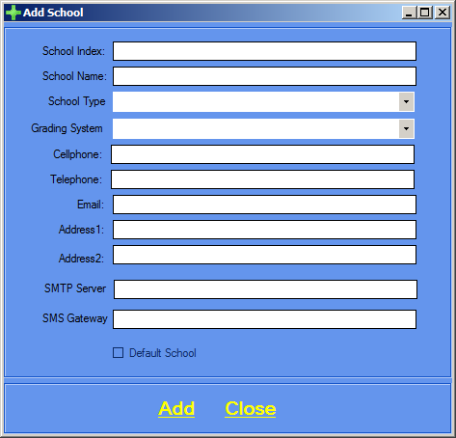

1. Type in School details.
2. Click Add then Close.

# : How to edit a School

1. Click Administrator on the menu bar.
2. Click School Set-Up.
3. Select the school you want to edit and click Edit. See example below.

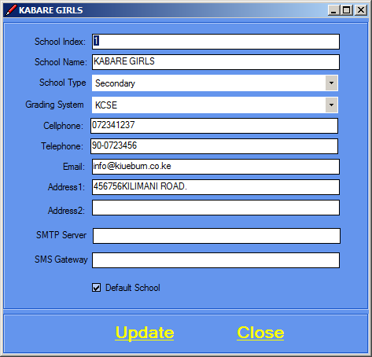

1. Edit school details.
2. Click Update then Close.

# : How to delete a School

**NB: You cannot delete a school if there are students associated with it. You must first delete the students associated with it.**

1. Click Administrator on the menu bar.
2. Click School Set-Up.
3. Select the school you want to delete and click Delete.

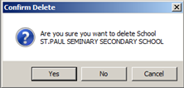

1. Confirm deletion by clicking Yes.
2. Click Close.
   1. Roles

# : How to add a Role

1. Click Administrator on the menu bar.
2. Click Roles.
3. The screen shown below will appear. 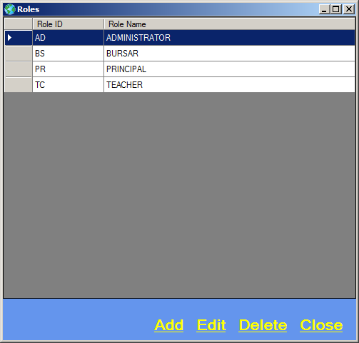
4. Click Add, the screen below will appear.

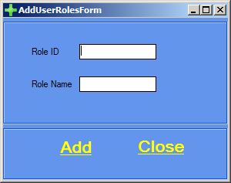

1. Type in the Role details.
2. Click Add.

# : How to edit a Role

1. Click Administrator on the menu bar.
2. Click Roles.
3. Select the Roles you want to edit and click Edit, the screen below will appear.

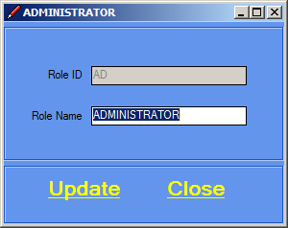

1. Edit user details.
2. Click Update then Close.

# : How to delete a Role

1. Click Administrator on the menu bar.
2. Click Roles.
3. Select the Role you want to delete and click Delete.

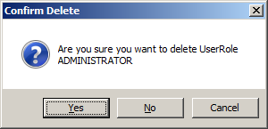

1. Confirm deletion by clicking Yes.
2. Click Close.
   1. Users

# : How to add a User

1. Click Administrator on the menu bar.
2. Click Users.
3. The screen shown below will appear.

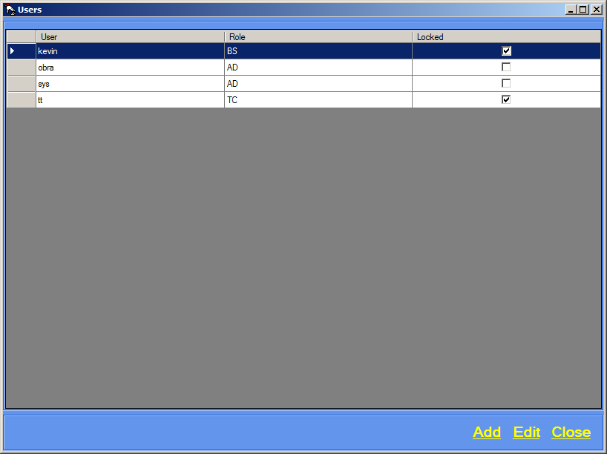

1. Click Add, the screen below will appear.

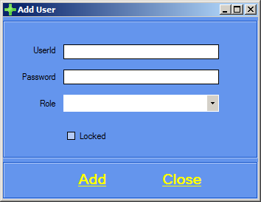

1. Type in the User details.
2. Click Add.

# : How to edit a User

1. Click Administrator on the menu bar.
2. Click Users.
3. Select the User you want to edit and click Edit, the screen below will appear.

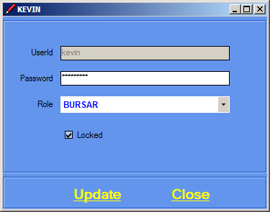

1. Edit user details.
2. Click Update then Close.

# : How to lock a User.

1. Click Administrator on the menu bar.
2. Click Users.
3. Select the User you want to lock and click Edit, the screen below will appear.

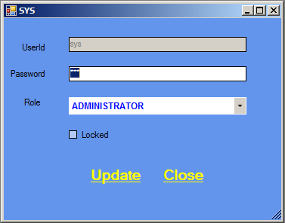

1. Click on the locked checkbox. See example below.

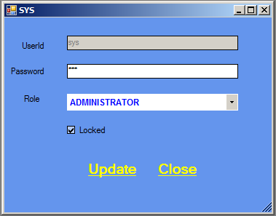

1. Click Update then Close.

# : How to unlock a User.

1. Click Administrator on the menu bar.
2. Click Users.
3. Select the User you want to unlock and click Edit, the screen below will appear.



1. Click on the locked checkbox. See example below.



1. Click Update then Close.
   1. Settings

# : How to change Settings

1. Click Administrator on the menu bar.
2. Click Settings.
3. The screen below will appear.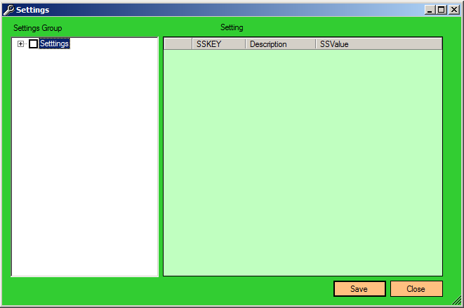
   1. Database Control Panel

# : How to view Database Control Panel

1. Click Administrator on the menu bar.
2. Click Database Control Panel.
3. The screen below will appear.

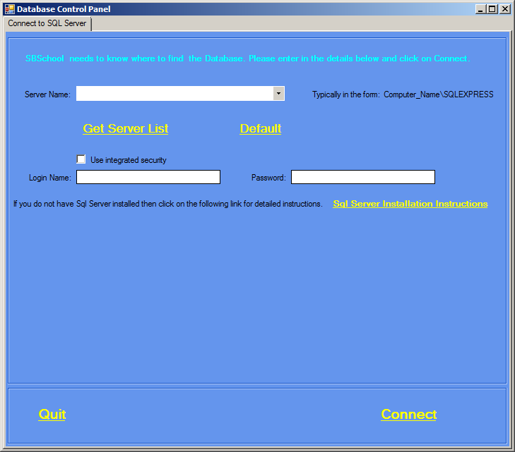

* 1. Upload/Download

HELP

* 1. Help
  2. About

# : About

1. Click Help on the menu bar.
2. Click About.
3. The screen below will appear with Help details.

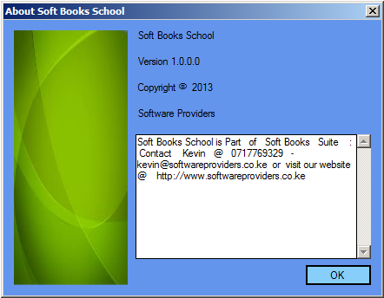

* 1. License

1. Click Help on the menu bar.
2. Click License.
3. The screen below will appear with Help details. 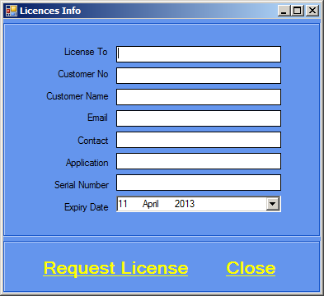
4. Type in details.
5. Click Request License.